DASTA which is the GSTC member and one of training partners has supported community-based tourism development. To ensure its sustainability of its supported project destinations, DASTA has decided to work with the GSTC on destination assessment to see its present status and make a strategic plan for improvement in order to achieve more sustainability.

February 2017, the Shukothai Historical Park went through a destination assessment and by Dr.Mihee Kang, GSTC Destination Assessor and Program Director for Asia-Pacific.

Sukhothai Historical Park is located on the lower edge of the northern region, 427 kilometers north of Bangkok and covers the ruins of the ancient glorious Sukhothai Kingdom, UNESCO declared it a World Heritage Site in December 1991. Sukhothai Historical Park attracted 1.01 milion visitors with 253,013 foreigners in 2016. There are 12 communities in and around the park and 7 of them are in the park. The communities established a cooperative organization of “Community Club” and the club and related government agencies including Sukhothai Historical Park work together for conservation and tourism development of Sukhothai.

It was very meaningful to assess the destination not only as a UNESCO World Heritage but also as a destination working closely with communities to get better ideas to improve its weakness and strength its strength to be a model of collaborative management in a heritage site.

The 3-day assessment had many meetings with various stakeholders from both private and public sectors and visited both the park and the communities. The assessment results based on the Assessor’s final report to DASTA were also presented in the International Conferences on Tourism held in Chiang Mai on 28 June-1 July by Dr. Panate Manomaivibool who took the Destination Liaison.

DASTA is planning to have the GSTC Destination Assessment for its another working destinations in 2018. Its movement for substantiality may push other government agencies in Thailand to take actions and the GSTC will support it.

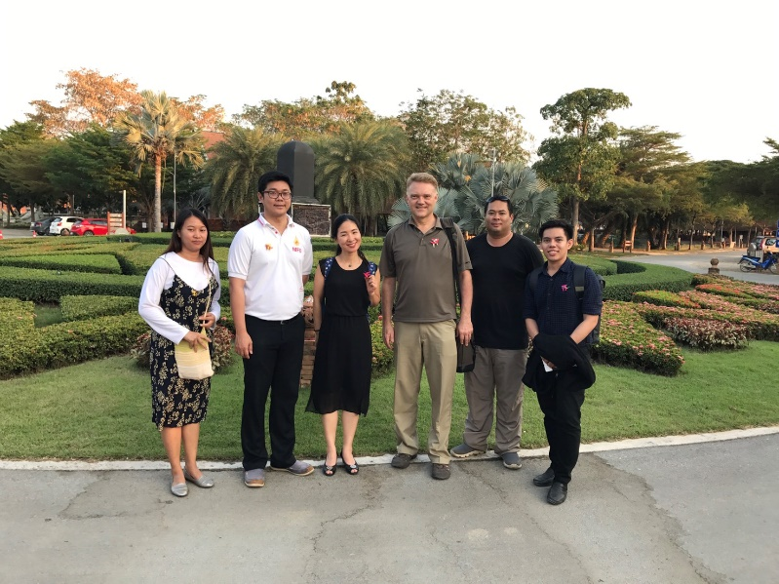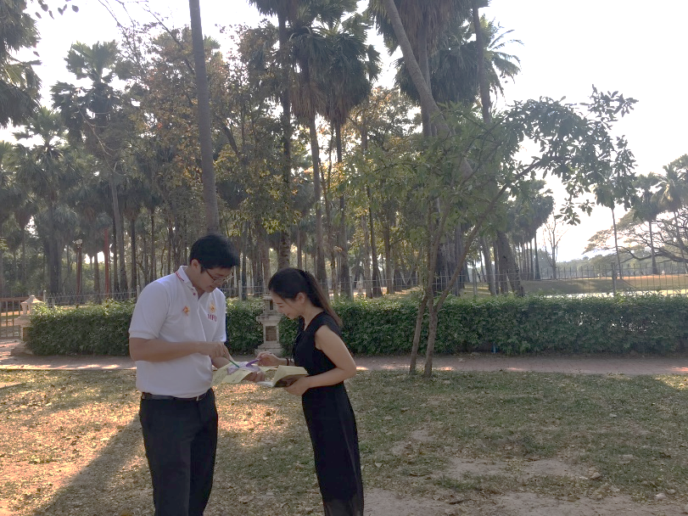

Figure 1. Destination Assessment team (DASTA, Destination Liaison Team, GSTC Assessor and CEO)

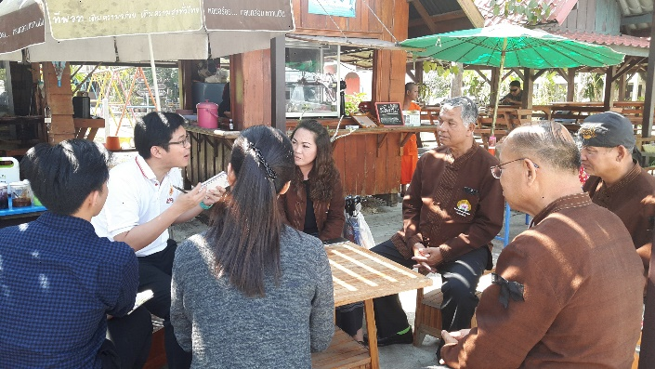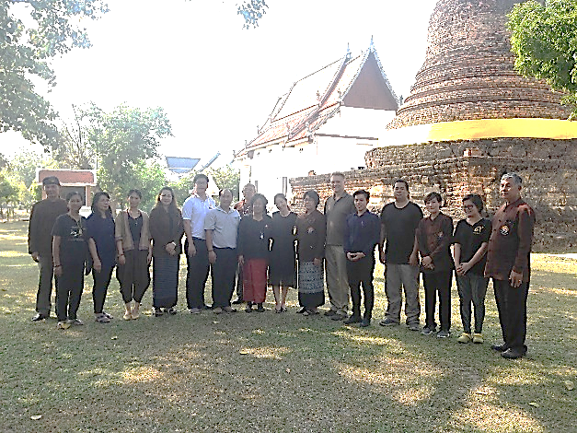

Figure 2. Interview with Community Club leaders & members

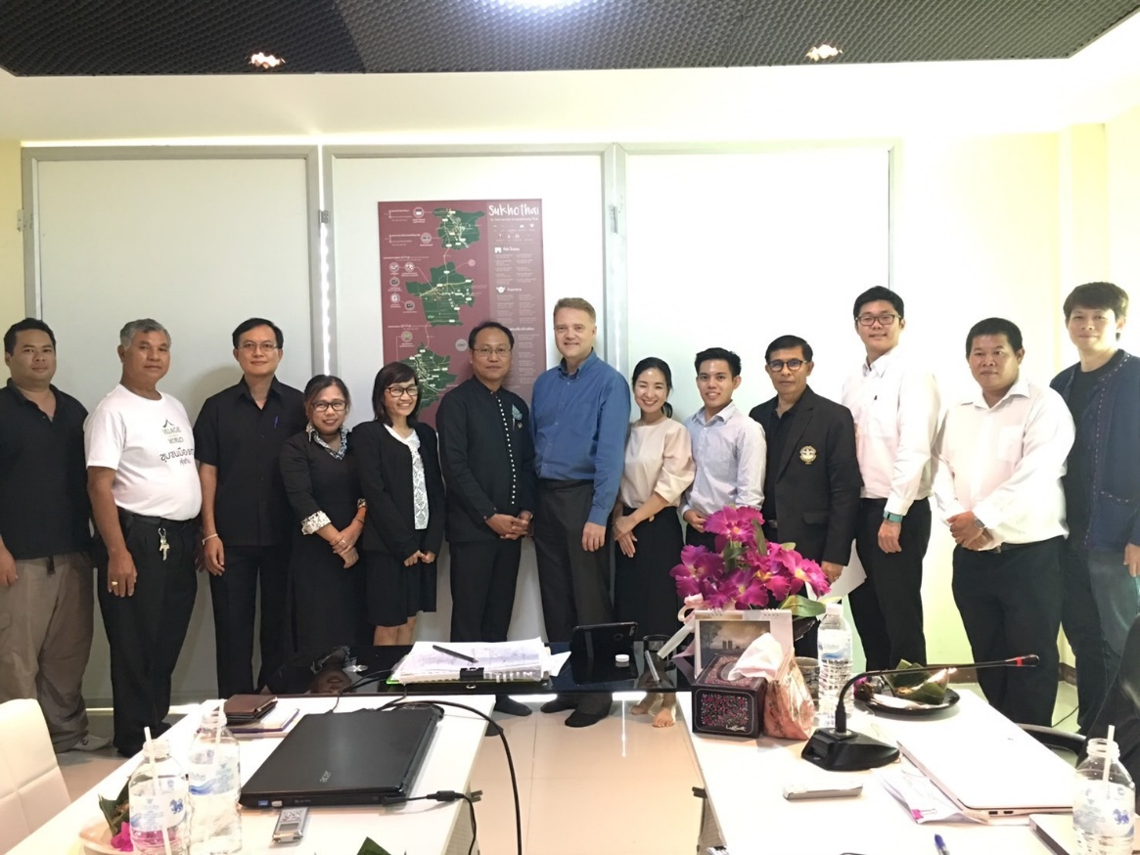

Figure 3. Group photo of stakeholders and assessment team