

The GSTC2025 Conference Took Place in Fiji with 350 Delegates from more than 40 Countries

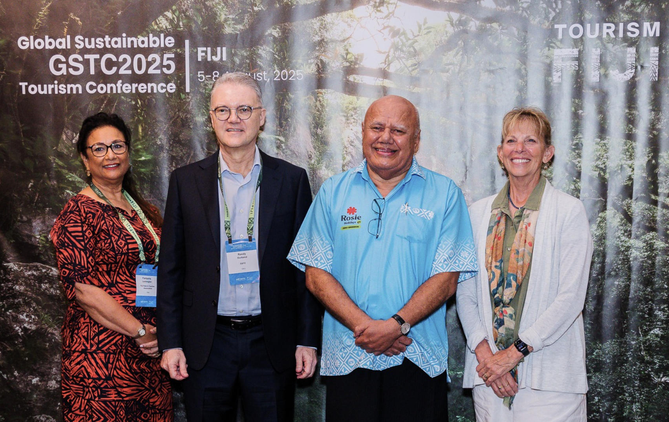

The [GSTC2025 Global Sustainable Tourism Conference](https://www.gstc.org/gstc2025fiji/) took place from 5 to 8 August at the Sheraton in Denarau, Fiji. The event brought together tourism professionals, destination representatives, academics, and sustainability experts from around the world to discuss key challenges and solutions in advancing sustainable tourism practices. Set against the backdrop of one of the world’s most iconic island destinations, the conference emphasized the importance of sustainable travel and destination stewardship, particularly in coastal and island contexts.

The event began with a two-day intensive [pre-conference training](https://www.gstc.org/gstc2025-pre-conference-training/) on Sustainable Tourism, held on August 3 and 4, where participants engaged in in-depth learning and dialogue. On August 5, the [III GSTC Academic Symposium](https://www.gstc.org/gstc2025fiji/academic-symposium/) took place, providing a platform for scholars and practitioners to present research and case studies related to sustainability, community engagement, and destination resilience.



A welcoming dinner was held for participants on the 5th, and a 'Salusalu' Fijian garland greeting was given to Mr. Randy Durband, GSTC CEO, and the Deputy Prime Minister and Minister for Tourism and Civil Aviation - Hon Viliame Gavoka, who delivered the welcoming.

Deputy Chair of Tourism Fiji Board, Ms. Fantasha Lockington, opened the day of the conference, alongside Dr. Kelly Bricker, Associate Dean of the HNU-ASU Joint International College (HAIC) and GSTC Vice-Chair, Randy Durband, GSTC CEO, and Dr. Mihee Kang, GSTC Chief Assurance Officer. They delivered the opening speeches that set the tone for the event, emphasizing the significance of sustainable tourism and a collective commitment to building resilient and responsible travel practices.

The [conference program](https://www.gstc.org/gstc2025fiji/program/) was structured around three core themes: Coastal & Island Tourism, Community, Culture, and Responsible Development, and Climate Resilience, Adaptation, and Sustainable Recovery. These thematic tracks provided a clear framework for the sessions, enabling participants to engage with relevant content provided by [renowned speakers](https://www.gstc.org/gstc2025fiji/speakers/).

The global conference, held on August 6 and 7, featured a wide range of sessions exploring pressing issues in tourism today, including panel discussions on Small Island Destination Management, Reef Protection, Coral Restoration, Responsible Diving, Sustainability in Attractions, Hospitality, Events, Sustainability Measurement and Evaluation, and Environmental Regeneration, among others.

“We work hard to operate conferences packed with useful and practical information and updates from real practitioners on solutions to the challenges of the transition to more sustainable forms of tourism. While maintaining a global perspective, by hosting GSTC2025 in Fiji, we included a focus on challenges and solutions unique to island nations. We thank the great support, warmth, and engagement of the Fiji tourism community, and wish them well in their efforts for [*loloma hour*](https://www.fiji.travel/loloma-hour) and all aspects of sustainability!”, said Mr. Durband.

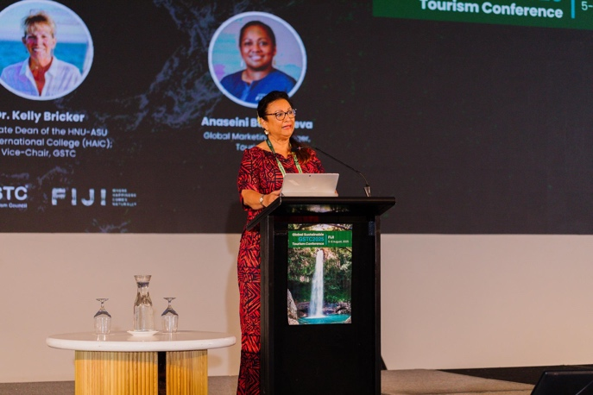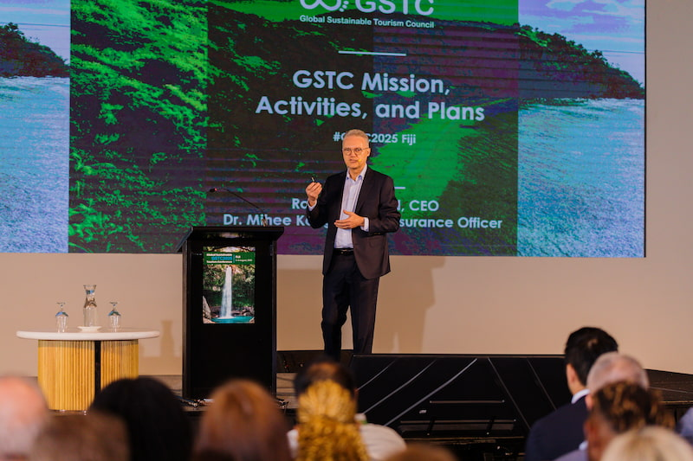

“The hosting of GSTC 2025 in Fiji is a proud achievement for our nation and the Pacific,” said Fantasha Lockington, Deputy Chair of the Tourism Fiji Board. “It showcased how our practical, community-driven approach to sustainability—through local engagement, electric mobility, and meaningful visitor experiences—can shape a more inclusive and resilient tourism future.”

“We’re also thrilled to see so many delegates getting out on famils and experiencing the warmth and beauty of Fiji—whether it’s their first visit or they’ve returned. Tourism Fiji’s budget for this event was spent locally—from accommodation and airfares to bands, caterers, and event companies. This ensures not only a global spotlight on Fiji and sustainable tourism, but also a direct financial benefit to our local economy. We’re proud to support local businesses through events like these, where the impact is both global and deeply local.”

The event also included two evening receptions that offered valuable networking opportunities and moments of cultural exchange in unforgettable settings. On 5 August, attendees gathered for the *Welcome Dinner at the Sofitel Fiji Resort and Sp*a, where they were greeted with traditional Fijian hospitality, live music, and a taste of the island’s culinary heritage. The evening served as a warm introduction to the conference, setting the tone for the days ahead. On 7 August, the *Farewell Dinner* took place at the *Sheraton Fiji Golf & Beach Resort*, bringing delegates together one last time. Both dinners provided a relaxed yet inspiring atmosphere that deepened connections among participants and highlighted the rich cultural traditions of Fiji.

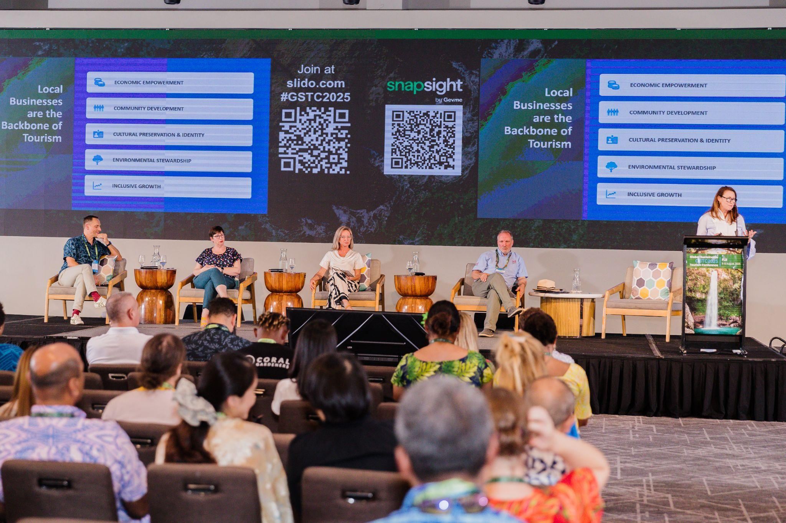

Recordings of the conference’s plenary sessions can be found on the [GSTC Facebook page](https://www.facebook.com/GlobalSustainableTourismCouncil) along with photographs of the event. Presentations from the various sessions will be available soon on [our website](https://www.gstc.org/gstc2025fiji/).

The conference featured a rich program of workshops that complemented the main sessions and consultation on the [GSTC Destination Standard](https://www.gstc.org/gstc-criteria/gstc-destination-criteria/) and the forthcoming [GSTC Food & Beverage Standard](https://www.gstc.org/gstc-to-develop-new-criteria-food-service-providers/).

Additionally, the event showcased a special session to introduce the project “Travel Redefined: Tourism for People and Planet,” produced by Content With Purpose (CWP) in partnership with GSTC. This preview screening introduced the GSTC’s new global video series, showcasing stories from around the world that will bring the [GSTC Standards](https://www.gstc.org/gstc-criteria/) to life.

Following the conference, participants were invited to explore Fiji through a variety of [post-conference tours](https://www.gstc.org/gstc2025fiji/post-conference-tours/). These included visits to local villages, cultural performances, and nature-based and community activities such as the [Naidiri Marine Biodiversity Park](https://naidirimarinebiopark.org/), designed to showcase the country’s commitment to sustainable tourism.

GSTC2025 Fiji served as a milestone event for the global sustainable tourism community, reinforcing the importance of collaboration, education, and local empowerment. By hosting the conference in Fiji, GSTC underscored the vital role that island destinations play in the global tourism ecosystem and the need for coordinated efforts to protect these environments.

### Carbon Footprint Measurement and Other Sustainable Practices during the Conference

As with previous GSTC Conferences, the carbon footprint of the event and the travel of all attendees is calculated and is being offset through ReForest. Other sustainable event practices were carried out, such as reducing paper and plastic usage to a minimum: printing to a minimum, badges made of recyclable paper, and no single-use plastic was used during the conference. Meals were made from locally sourced produce and were mostly vegetarian.

[Reforest](https://reforest.com.au/), an Australian social enterprise dedicated to helping travel and events leave a positive legacy for climate, nature, and local communities, served as a sustainability partner for GSTC2025 in Fiji. As part of this collaboration, Reforest is planting a tree on behalf of every attendee, in partnership with Conservation International, through a local reforestation project in the Ra Province on the island of Viti Levu. Each tree planted will contribute to removing CO₂ from the atmosphere, restoring degraded landscapes to support wildlife, and creating sustainable livelihood opportunities for nearby villages.

Embracing the concept of slow travel, GSTC2025 participants were encouraged to extend their stay in Fiji, with some staying as long as 20 days. The average stay among international participants was 7.3 days.

As a global organization, GSTC rotates its annual conference across different regions of the world each year to ensure inclusivity and representation. This approach allows stakeholders from diverse regions to participate in person without always having to travel long distances. Hosting the 2025 conference in Fiji is part of this commitment, following conferences in [Singapore](https://www.gstc.org/gstc2024-conference-in-sentosa-singapore-concluded-with-500-delegates-from-55-countries/) (2024), [Spain](https://www.gstc.org/gstc2022-global-conference-in-seville-andalusia-spain/) (2022), [Botswana](https://www.gstc.org/the-global-sustainable-tourism-conference-2018-in-maun-botswana-gstc2018/) (2018), [Chile](https://www.gstc.org/sustainable-destinations-leading-themes-global-sustainable-tourism-conference-2017-aysen-chile/) (2017), and other regions in previous years.

Fiji, as a small island developing state (SIDS), faces unique challenges related to climate change and tourism sustainability. By hosting the conference here, GSTC aims to highlight these issues on a global stage and provide a platform for local stakeholders to engage directly with international experts. Avoiding such destinations would risk marginalizing their voices and further isolating them from global discussions—a perspective GSTC believes is critical to avoid.

Avoiding tourism to islands entirely would make them double-victims of climate change: suffering the negative physical impacts of climate change along with decreased economic benefits from reduced demand.

### Acknowledgments

Our deep gratitude to [Tourism Fiji](https://www.fiji.travel/) and all who participated in making this event possible. Our Exhibitors at the event were: [Tourism Fiji](https://www.fiji.travel/), [TUV Rheinland](https://www.tuv.com/), [Control Union](https://www.controlunion.com/), [Reforest](https://reforest.com.au/), [Hotelzero](https://www.hotelzero.io/), [Content with Purpose (CWP)](https://contentwithpurpose.co.uk/), and [Phuket](https://www.tourismthailand.org/Destinations/Provinces/Phuket/350). Media Partners were [DestinAsia,](https://destinasian.com/) [Travel Voice Japan](https://www.travelvoice.jp/english/), and [Travel and Tour World](https://www.travelandtourworld.com/), which we want to thank for their support in spreading the news about the Conference.

As well as all the other event sponsors, such as [Booking.com](http://booking.com), [Rosie Holidays](https://rosiefiji.com/), [Gevme](https://www.gevme.com/en/), [Destination Wayfinder](https://www.destinationwayfinder.com/), as well as GSTC’s Gold Sponsors, [Türkiye Tourism Promotion and Development Agency (TGA)](https://tga.gov.tr/en/about-us), and [Visit Sweden](https://visitsweden.com/), for their continued support. Special thanks to GSTC’s Platinum Sponsor, [Traveloka](https://www.traveloka.com/en-en), for their outstanding commitment to promoting sustainable tourism and fostering positive change within the industry.

Thank you all for making an unforgettable GSTC2025 in Fiji. For updates about future conferences and other important developments, sign up for the [GSTC monthly newsletter](https://www.gstc.org/mailing-list-subscription/).

### Upcoming GSTC2026 Global Conference

The next GSTC Conference will be #GSTC2026 Phuket, Thailand (21st to 24th of April 2026). [Register here](https://gstcouncil.us2.list-manage.com/subscribe?u=f46198bfc5b1630821e955309&id=20ba519691) to get notified when early bird registration opens!

**#END#**

About GSTC

The Global Sustainable Tourism Council® (GSTC®) establishes and manages global sustainable standards, the GSTC Standards, also known as the GSTC Criteria. The [GSTC Destination Standard](https://www.gstc.org/gstc-criteria/gstc-destination-criteria/) for public policy-makers and destination managers, [GSTC Hotel Standard & GSTC Tour Operator Standard](https://www.gstc.org/gstc-criteria/gstc-industry-criteria/), [GSTC MICE Standard](https://www.gstc.org/gstc-criteria/gstc-mice-criteria/) for Venues, Event Organizers, and Events & Exhibitions, and the [GSTC Attraction Standard](https://www.gstc.org/gstc-criteria/gstc-attraction-criteria/) for tourist attractions such as theme parks, museums, and national parks. These are the guiding principles and minimum requirements that any tourism business or destination should aspire to reach in order to protect and sustain the world’s natural and cultural resources while ensuring tourism meets its potential as a tool for conservation and poverty alleviation.

The GSTC Standards form the foundation for GSTC’s assurance role for Certification Bodies that certify hotels/accommodations, tour operators, and destinations as having sustainable policies and practices in place. GSTC does not directly certify any products or services but provides accreditation to those that do.

GSTC is an independent and neutral USA-registered 501(c)3 non-profit organization that represents a [diverse and global membership](https://www.gstc.org/membership/member-search/), including national and provincial governments, leading travel companies, hotels, tour operators, NGOs, individuals and communities – all striving to achieve best practices in sustainable tourism. The GSTC is an [ISEAL Community Member](https://www.isealalliance.org/iseal-community-members), a global membership organization for ambitious, collaborative, and transparent sustainability systems.

Information for media and the press: [www.gstc.org/about/for-the-press/](http://www.gstc.org/about/for-the-press/)