

**THE LARGEST GSTC GLOBAL CONFERENCE TOOK PLACE IN STOCKHOLM WITH THE PRESENCE OF HER ROYAL HIGHNESS OF SWEDEN, CROWN PRINCESS VICTORIA**

The **GSTC2024 Global Sustainable Tourism Conference,** which took place in Stockholm, Sweden, from April 23rd to April 26th, 2024, brought together 500 delegates from more than 50 countries, along with hundreds of viewers who watched the live broadcasting of the conference.

The conference was held in **Royal Djurdgården** in two venues: Day 1 of the Global Conference took place at Cirkus and Hasselbacken, and Day 2 took place at three different museums: Museum of Technology, Maritime Museum, and the Museum of Ethnography. The Conference themes were: (A) Environment – Climate and Smart Management; (B) Social – Welcoming and Inclusive; (C) Governance – Thriving and Innovative; (D) Credible Assurance.

Participants included international and regional tourism stakeholders involved in the development and promotion of sustainable tourism, including the public sector, hotels, tour operators, academia, development agencies, NGOs, consultants, and more. International participants came from Europe, North America, Latin America, Africa, Asia, and Oceania.

The **Royal Highness of Sweden**, **Crown Princess Victoria**, attended the conference's opening ceremony, where former Prime Minister Fredrik Reinfeld, Visit Sweden's Chief Executive Officer Susanne Andersson, General Secretary of the Swedish Agency for Economic and Regional Growth Elisabeth Backteman, and GSTC Chair Luigi Cabrini made the opening speeches.

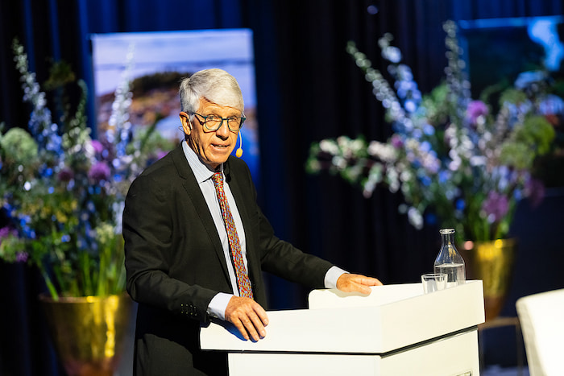“International tourism has almost reached its pre-pandemic levels with Europe leading the recovery, and some destinations are registering the highest number of visitors ever. Tourism has regained its potential as an essential economic activity, a creator of jobs, and a tool for development.

At the same time, international tensions are high and wars are ravaging in different regions of the world. It seems a paradox that when globalization and the opening of borders make it possible for people to travel freely around the continents, conflicts that we thought would never occur again, are spreading, with their corollary of human loss and destruction.

Tourism from its very beginnings has been defined as a way of promoting mutual understanding, respect, and tolerance. But its full potential as an instrument for peace clearly remains to be realized.” said **Mr. Cabrini.** (Full speech can be found [here](https://www.gstcouncil.org/wp-content/uploads/Luigi-Cabrini-GSTC-Chair-Opening-speech.pdf))

[Speakers](https://www.gstcouncil.org/gstc2024sweden/speakers/) from across the world shared insights and discussed the following topics: Tourism Supporting Biodiversity through Nature Positive and Rewilding, Food Waste Reduction, Sustainability in Attractions, Data-based Innovation in Tourism, Green Mobility, Destination Stewardship and Guest Experience, Accessibility and Inclusion in Tourism, among many others. (See [here](https://www.gstcouncil.org/gstc2024sweden/program/) the full conference program.)

Prior to the conference, four onsite **GSTC Trainings** took place in Stockholm:

* GSTC Sustainable Tourism Course in [English](https://www.gstcouncil.org/sustainable-tourism-course-sweden-april-2024-en/) and [Swedish](https://www.gstcouncil.org/sustainable-tourism-course-sweden-april-2024-se/) for Industry Professionals, the training specifically focused on the [GSTC Criteria](https://www.gstcouncil.org/gstc-criteria/), the global standards for sustainability in tourism and travel.
* [GSTC Accessibility and Social Impact in Tourism Course](https://www.gstcouncil.org/accessibility-social-impact-course-sweden-april-2024/), designed to empower participants with essential knowledge and skills to tap into the thriving accessible and inclusive travel and provide best practices in diversity, equity and inclusion (DEI).
* and [GSTC Auditor Training](https://www.gstcouncil.org/auditor-training-stk-apr-2024/), which covered the GSTC Industry Criteria, the audit process, and key issues auditors needed to be aware of.

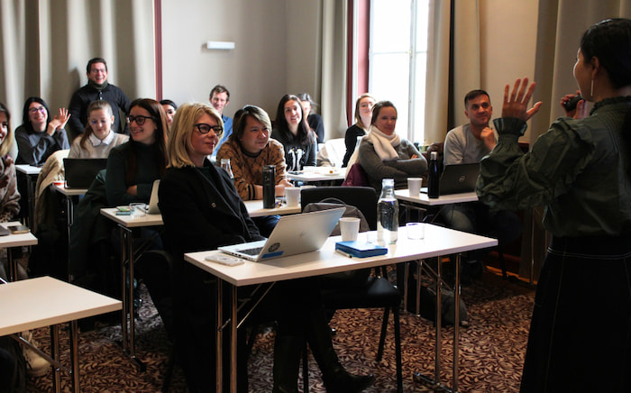A total of 90 industry professionals joined the training from across Europe and globally. Using the [GSTC Industry Criteria](https://www.gstcouncil.org/gstc-criteria/gstc-industry-criteria/) and [GSTC Destination Criteria](https://www.gstcouncil.org/gstc-criteria/gstc-destination-criteria/) as the foundation, the training class covered various topics relevant to our industry and the sustainability challenges and opportunities we are facing today. The [2nd GSTC Academic Symposium](https://www.gstcouncil.org/second-gstc-academic-symposium-concluded-successfully/) was also held in conjunction with the Global Sustainable Tourism Conference for the second time. The symposium provided a forum for researchers and academics to share and discuss current issues in sustainable tourism.

Recordings of the conference’s plenary sessions can be found on the [GSTC Facebook page](https://www.facebook.com/GlobalSustainableTourismCouncil/videos/) and the other sessions will soon be uploaded to our [GSTC YouTube channel](https://youtube.com/playlist?list=PLm4B_omiA_xDrE_72-7u-ydi8Guw-3CSY). Pictures from the event can be found on our Facebook Albums [here](https://www.facebook.com/GlobalSustainableTourismCouncil/photos_albums). The presentations from each session can be accessed [here](https://www.gstcouncil.org/gstc2024sweden/program/).

### Carbon Footprint Measurement and Other Sustainable Practices during the Conference

As with previous GSTC Conferences, the carbon footprint of the event and the travel of all attendees have been calculated, and offset by Visit Sweden. Other sustainable event practices were carried out, such as reducing paper and plastic usage to a minimum: printing to the minimum, badges made of recyclable paper, and no single-use plastic used during the conference. Meals were strictly vegetarian, while most dishes were fully vegan. Public transport was encouraged as well as walking distance venues for the event were provided.

### Acknowledgments

Our profound gratitude to all of those who have participated in making this event possible: Visit Sweden and the Swedish Agency for Economic and Regional Growth as coorganizers of the event, as well as support from Visit Stockholm and Royal Djurgården Society.

Our Exhibitors at the event were Planhotel, GSTC Training Team, CRiS Technologies, Singapore Tourism Board, Lufthansa, APT Valsugana (Italy Working Group), Suwon City, Türkiye Tourism Promotion and Development Agency (TGA), and Botswana Tourism Organisation.

Our Media Partners were Travelmole, Sustainable Hotel News, TravelNews, Travel and Tour World, and India Outbound, which we want to thank for their support in spreading the news about the Conference.

Thank you all for making an unforgettable #GSTC2024 in Stockholm, Sweden.

For updates about future conferences and other important developments, [sign up for the GSTC monthly newsletter](https://www.gstcouncil.org/mailing-list-subscription/).

### Upcoming GSTC2024 Global Conferences

The next GSTC Conference will be [#GSTC2024Singapore](https://www.gstcouncil.org/gstc2024singapore/) (13th to 16th November 2024). Early bird registration for Sentosa, Singapore, is currently open. Click here to save your spot: <https://www.gstcouncil.org/gstc2024singapore/>

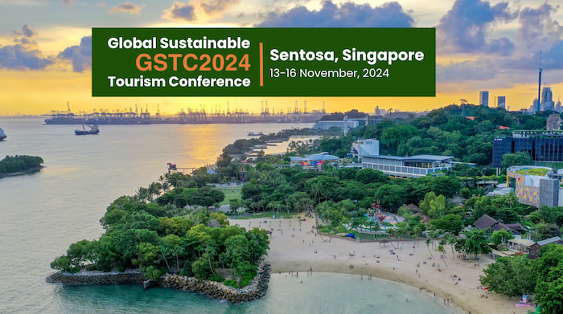

At the Farewell Dinner, the next Global Conferences for 2025 and 2026 were announced by Randy Durband, GSTC CEO.

#GSTC2025Fiji

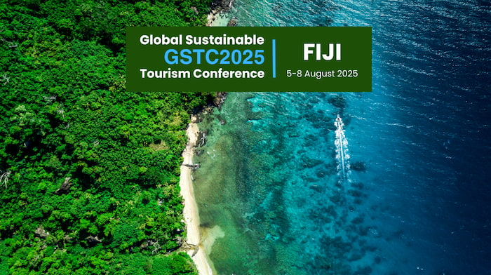

#GSTC2026Phuket

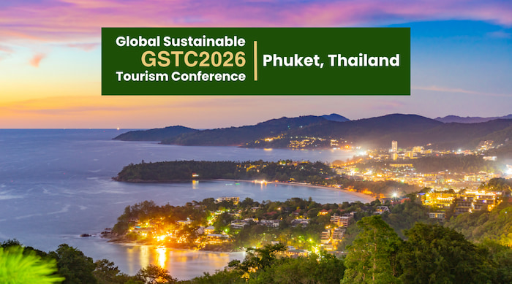

**#END#**