Travel Redefined:

Tourism for People and Planet
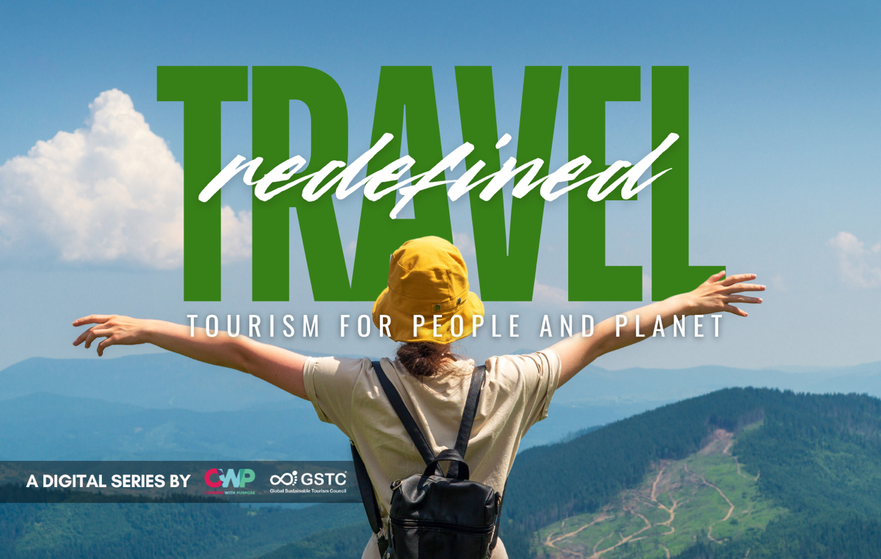

The Global Sustainable Tourism Council (GSTC) is proud to launch its first global digital travel series, Travel Redefined: Tourism for People and Planet, in partnership with Content With Purpose the strategic content creator that empowers sustainable development.
As the world embarks on a new era of travel, this dynamic new digital film series supports the urgent need - and growing momentum - for sustainability practices in tourism worldwide. Travel Redefined takes an in-depth look into how sustainable and regenerative tourism supports people, planet, and prosperity by sharing real stories and expert insights from inspiring people and organisations around the world. Travel Redefined will be available to stream online from 6:00AM GMT, August 19, 2025 here.
With global tourism making a full recovery – the World Tourism Barometer from UN Tourism reported that in Q1 2025, international tourist arrivals grew 5 percent compared to 2024, putting the industry on track to reach a new record this year – there is an urgency to rethink how the industry operates. Climate change, biodiversity loss, and overtourism are pressing challenges that demand action now. This landmark digital series is a global call to action to build awareness of tourism’s potential to create positive social, cultural, environmental, and economic change. From policymakers, industry leaders, travellers, and changemakers – it’s an invitation to see how tourism can always be part of the solution.
Randy Durband, CEO of GSTC, said, “Travel Redefined is a powerful reminder that every journey holds the potential to leave a positive legacy.” He added, “Many of the featured stories come from GSTC Members who are already putting these values into practice. They serve as real-world examples of what’s possible when sustainability is placed at the heart of tourism.”
Filmed across six continents, solely using local film crews to minimise travel and production emissions, the ambitious series spanned over 50 filming days to create 24 cinematic short films, 22 thought leadership videos, 10 expert interviews and three case studies. All of the films in the series showcase sustainable best practice and examine the role of tourism in promoting biodiversity conservation, carbon reductions, green mobility, responsible waste practices, equitable economic development, cultural preservation, and accessible experiences.
Max Smith, Founder and Managing Director at Content With Purpose, said, “We have embedded sustainability into every step, reflecting our environmental commitments, from using local crews to telling real-life stories that empower communities and protect the planet - proving that a flourishing, sustainable industry isn’t a distant vision. It’s happening right now, and we all have a role to play in this transformation.”
From the coasts of California to community-led conservation in The Philippines, Travel Redefined takes viewers on a journey across continents to meet pioneers who are radically re-thinking tourism to make it work for people and the planet.
Key sustainability themes covered in the short films include:
- Rebuilding with roots: how mangroves and tourism are restoring The Bahamas - The Bahamas Ministry of Tourism.
- How social media and digital detox are shaping the future of travel - University of Greenwich
- Developing a new destination responsibly in Finland’s Turku Archipelago - Visit Turku Archipelago
- How community tourism can help protect the amazon and preserve indigenous culture – G Adventures
This is just a small insight into the wide-ranging series. Begin your journey here.

ENDS
Notes to editors:
The Travel Redefined series features:
Series Partners: Ascott, Mandai Wildlife Group, South Australia Tourism Commission, University of Greenwich, Victoria University, Visit Iceland, Visit Tallinn, Intrepid Travel, California State University Monterey Bay, Cook Islands Tourism Corporation, Destination Québec Cité, Eurail, G Adventures, Gardens by The Bay, Guyana Tourism Authority, Innovation Norway, Promperú , San Vigilio Dolomites, Tahiti Tourisme, The Bahamas Ministry of Tourism, Tourism New Zealand, Visit Isle of Man, Visit Laguna Beach, Visit Turku Archipelago.
Case Studies: Rhino Conservation, Kenya, Papagayo Peninsula, Costa Rica, Trentino, Italy
Expert Interviews:
- Agathe Daudibon, Director of EuroVelo & Cycling Tourism, European Cyclists' Federation
- Deborah Rothe, Director, ITB Berlin
- Guy Bigwood, CEO and Chief Changemaker, Global Destination Sustainability Movement
- Hina Umer, Co-founder and Business Development Lead, Beyond the Valley
- Mich Goh, Director of Public Policy APAC, Airbnb
- Peter Semone, Chair, Pacific Asia Travel Association (PATA)
- Professor Hasan Ali Karasar, Rector, Cappadocia University
- Professor Stefan Gössling, Professor of Tourism, Linnaeus University
- Randy Durband, CEO, Global Sustainable Tourism Council (GSTC)
- Robert Thompson, Executive Director of Regions, Tourism Fiji
About GSTC
The Global Sustainable Tourism Council® (GSTC®) establishes and manages global sustainable standards, the GSTC Standards, also known as the GSTC Criteria. The GSTC Destination Standard for public policy-makers and destination managers, GSTC Hotel Standard & GSTC Tour Operator Standard, GSTC MICE Standard for Venues, Event Organizers, and Events & Exhibitions, and the GSTC Attraction Standard for tourist attractions such as theme parks, museums, and national parks. These are the guiding principles and minimum requirements that any tourism business or destination should aspire to reach in order to protect and sustain the world’s natural and cultural resources while ensuring tourism meets its potential as a tool for conservation and poverty alleviation.
The GSTC Standards form the foundation for GSTC’s assurance role for Certification Bodies that certify hotels/accommodations, tour operators, and destinations as having sustainable policies and practices in place. GSTC does not directly certify any products or services but provides accreditation to those that do.
GSTC is an independent and neutral USA-registered 501(c)3 non-profit organization that represents a diverse and global membership, including national and provincial governments, leading travel companies, hotels, tour operators, NGOs, individuals and communities – all striving to achieve best practices in sustainable tourism. The GSTC is an ISEAL Community Member, a global membership organization for ambitious, collaborative, and transparent sustainability systems.

About CWP
Content With Purpose (CWP) is a strategic content creator that partners with leading member bodies and associations to highlight their industries’ contributions to sustainable development. Through compelling storytelling, CWP produces and promotes impactful digital series - featuring short documentaries, interviews, articles, and more - designed to raise awareness, drive change, and promote innovation across key sectors.
The organisation’s mission is to communicate hope, opportunity, and solutions - connecting people with ideas that inspire action and collaboration. As a proud B Corp Certified company, CWP is committed to using business as a force for good.

