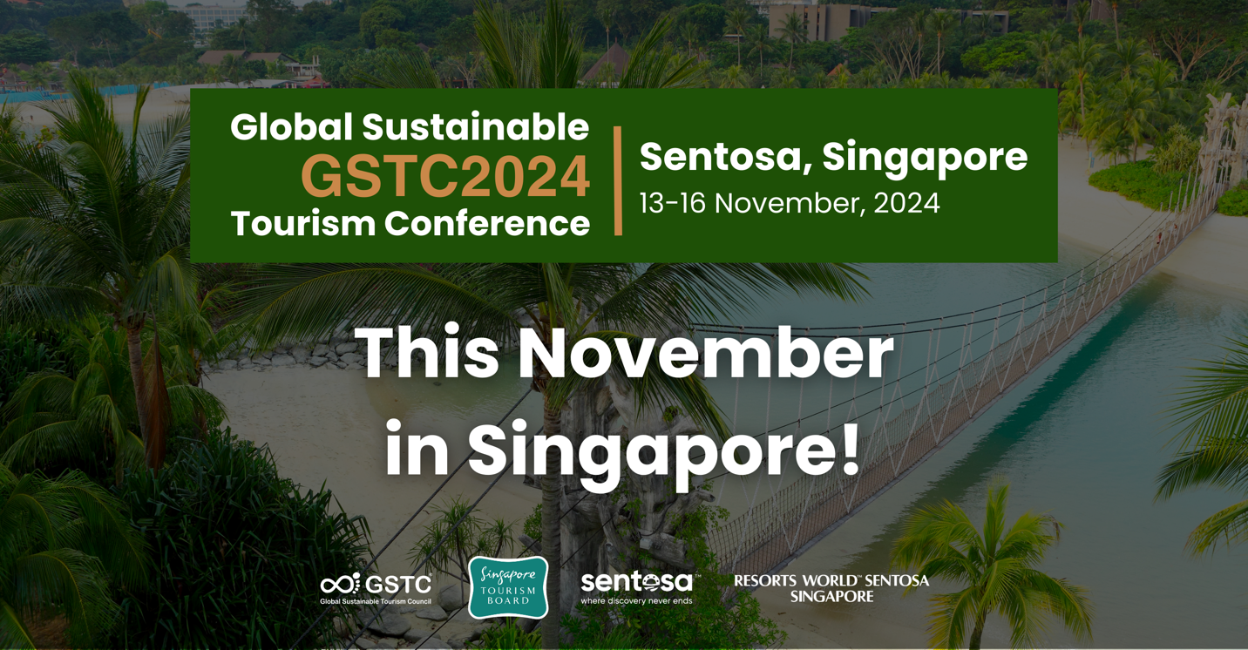
The GSTC Global Sustainable Tourism Conference will take place in Sentosa, Singapore, This November!

The Global Sustainable Tourism Council (GSTC) will be holding the GSTC2024 Global Sustainable Tourism Conference in Sentosa, Singapore, from November 13th-16th, 2024, seeking to bring together global and local tourism professionals committed to promoting and advancing sustainable travel and tourism.

The conference will be held at the Equarius Hotel, which is certified against GSTC Industry Criteria for Hotels. The hotel is located within Resorts World Sentosa, the first destination in the world certified to both the GSTC Destination Criteria and GSTC Industry Criteria for Hotels in 2021. Additionally, both Sentosa and Singapore are also certified as sustainable destinations, further enhancing the credentials of the event's setting.

The GSTC2024 Global Sustainable Tourism Conference in Sentosa will draw representatives from a wide range of sectors, including government, hotels, tour operators, businesses, academia, development agencies, online travel platforms, and NGOs.

GSTC2024 Singapore will focus on four core themes:
- Driving Sustainable Urban Tourism
- Sustainable Hospitality
- Integrating Sustainability across the Value Chain
- Preserving Culture, Heritage and Communities

Through these themes, the conference aims to equip participants with the knowledge and practical skills needed to drive progress in their sustainability journey. With renowned speakers from the tourism industry sharing their expertise, the event fosters collaboration and innovation, inspiring meaningful change that positively impacts both the environment and local communities.
The two-day Conference offers a rich agenda featuring pre-conference training, interactive panels, workshops, meetings, and networking opportunities, as well as tailored post-conference tours.

Attendees will have the opportunity to experience the charm of Sentosa while exploring the island’s sustainability initiatives through these curated tours. Each tour offers a unique perspective on how Sentosa and its partners are pioneering eco-friendly tourism, whether by delving into behind-the-scenes operations at Resorts World Sentosa, discovering the natural beauty and eco-conscious practices of the Southern Islands, or uncovering the island’s rich heritage. These experiences highlight Sentosa's commitment to sustainable development and provide participants with valuable insights into the efforts being made to balance tourism with environmental conservation.

Ms Ong Huey Hong, Chief Sustainability Officer, Singapore Tourism Board, said: “Hosting the GSTC2024 Global Sustainable Tourism Conference highlights Singapore’s appeal as a Global-Asia node for quality events and underscores our commitment to sustainable tourism. Guided by the Singapore Green Plan, our sustainable tourism strategy aims to build a City in Nature, where large experiences come with small footprints. We are committed to supporting the tourism industry in their sustainability journey, including pushing boundaries in innovation by leveraging technology, and enhancing the green skills of our workforce such as in Certification and Reporting and Carbon Management. This conference will serve as a crucial platform for global leaders to convene, exchange insights, and collaboratively forge new partnerships in sustainable tourism, inspiring meaningful impact worldwide.”

Mr Lee Cheh Hsien, Assistant Chief Executive, Corporate and Sustainability, Sentosa Development Corporation said, "Being the first destination in Asia to be certified to GSTC’s destination standards, we are honoured to host GSTC’s first global conference in Southeast Asia and look forward to the learnings and exchanges amongst global experts and participants. We welcome them to immerse themselves in Sentosa's lush nature and heritage sites and experience first-hand the sustainability initiatives championed by the businesses across our island ecosystem.”
Ms Lee Shi Ruh, President, Resorts World Sentosa, said: "Being the first destination in the world certified to both the GSTC Destination Criteria and GSTC Industry Criteria for Hotels in 2021, Resorts World Sentosa is honored to play a pivotal role in hosting the GSTC2024 Global Sustainable Tourism Conference at Equarius Hotel this November. We are excited to support the conference's mission to promote sustainable travel and tourism, as we work together with our stakeholders and the local community to build a sustainable future for Sentosa. At RWS, we are making significant progress toward becoming a carbon-neutral destination by 2030, focusing on decarbonization, sustainable infrastructure, and green job creation. As part of the conference, we are pleased to introduce a guided tour that takes delegates behind the scenes of our lush integrated resort, highlighting innovations such as our district cooling plant and cloud-based Building Management System and their impact on advancing our vision of RWS being a sustainable tourism destination."
Registration is open for the GSTC2024 Global Sustainable Tourism Conference, where leaders, experts, and relevant stakeholders across the tourism industry will gather to collaborate and guide the future of sustainable travel.
For more information, please visit www.gstcouncil.org/gstc2024singapore/
#END#

About GSTC
The Global Sustainable Tourism Council® (GSTC®) establishes and manages global sustainable standards, known as the GSTC Criteria. There are three sets: Destination Criteria for public policy-makers and destination managers, Industry Criteria for Hotels and Tour Operators, and MICE Criteria for Venues, Event Organizers, and Events & Exhibitions. These are the guiding principles and minimum requirements that any tourism business or destination should aspire to reach in order to protect and sustain the world’s natural and cultural resources while ensuring tourism meets its potential as a tool for conservation and poverty alleviation.

The GSTC Criteria form the foundation for GSTC’s assurance role for Certification Bodies that certify hotels/accommodations, tour operators, and destinations as having sustainable policies and practices in place. GSTC does not directly certify any products or services, but provides accreditation to those that do.

GSTC is an independent and neutral USA-registered 501(c)3 non-profit organization that represents a diverse and global membership, including national and provincial governments, leading travel companies, hotels, tour operators, NGOs, individuals and communities – all striving to achieve best practices in sustainable tourism. The GSTC is an ISEAL Community Member, a global membership organization for ambitious, collaborative, and transparent sustainability systems.

Information for media and the press: www.gstcouncil.org/about/for-the-press/

About the Singapore Tourism Board
The Singapore Tourism Board (STB) is the lead development agency for tourism, one of Singapore’s key economic sectors. Together with industry partners and the community, we shape a dynamic Singapore tourism landscape. We bring the Passion Made Possible brand to life by differentiating Singapore as a vibrant destination that inspires people to share and deepen their passions.

More: www.stb.gov.sg or www.visitsingapore.com | Follow us: STB LinkedIn, STB Facebook or STB Instagram
About Resorts World Sentosa
Resorts World Sentosa Pte Ltd (RWS) is wholly owned by Genting Singapore Limited (GENS), a brand leader in sustainable integrated resort (IR) development and management, with a mission to develop world-class integrated resorts that transform destinations, create jobs, and reinvest in local economies through sustainability-conscious practices. GENS’ strong ESG credentials include being listed in several key indices such as the SGX ESG Leaders Index, FTSE4Good Developed Market index and ASEAN5 index, as well as Bloomberg Gender-Equality Index.
GENS is recognised for Singapore’s first IR, Resorts World Sentosa. Spanning across a 49-hectare site, the award-winning destination features world-class attractions, luxury hotels, MICE facilities, entertainment, lifestyle offerings and more, providing a unique blend of business, lifestyle, entertainment, and educational experiences. With a vision to transform into a leading sustainable tourism destination, RWS is actively pursuing carbon neutrality by 2030 through advancing decarbonization, energy efficiency, sustainable infrastructure, green job creation and sustainability research.
For more information, please visit www.rwsentosa.com and www.gentingsingapore.com.

