**GSTC2024 Conference in Sentosa, Singapore, Concluded with 500 Delegates From 55 Countries**

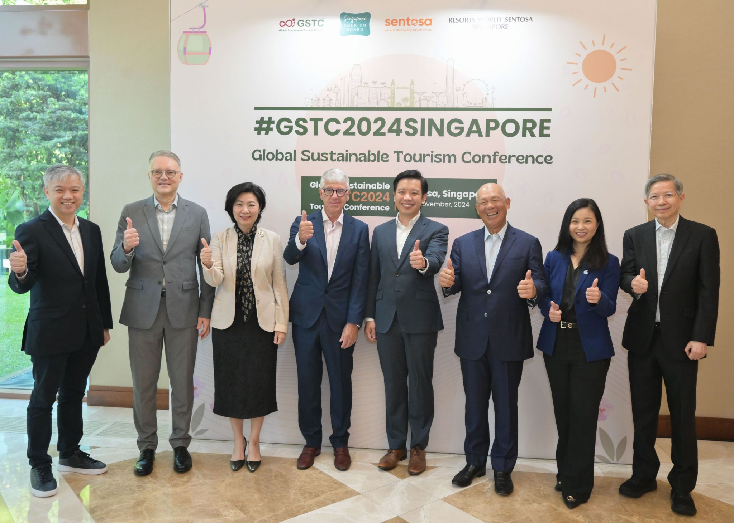The **GSTC2024 Global Sustainable Tourism Conference**, which took place in Sentosa, Singapore from November 13th to November 16th, 2024, brought together 500 delegates from 55 countries, along with hundreds of viewers who watched the live broadcasting of the conference.

The Conference themes were: (A) Driving Sustainable Urban Tourism; (B) Sustainable Hospitality; (C) Integrating Sustainability across the Value Chain; (D) Preserving Culture, Heritage and Communities. Through these themes, the conference provided participants with the insights, inspirational examples and practical skills needed to drive progress in their sustainability journey. With [renowned speakers](https://www.gstcouncil.org/gstc2024singapore/speakers/) from the tourism industry sharing their expertise, the event fostered collaboration and innovation, inspiring meaningful change that positively impacts both the environment and local communities.

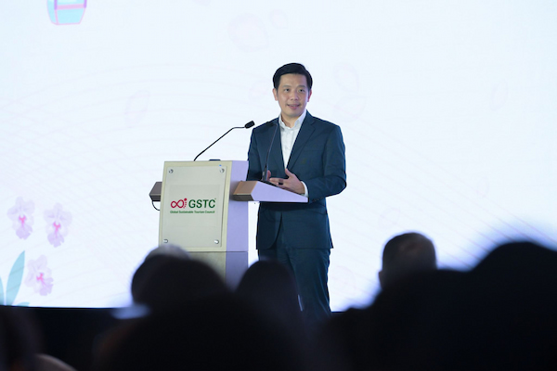Participants included international and regional tourism stakeholders involved in the development and promotion of sustainable tourism, including the public sector, hotels, tour operators, academia, development agencies, NGOs, consultants, and more.

**Mr. Alvin Tan, Minister of State, Ministry of Trade and Industry & Ministry of Culture, Community and Youth** opened the conference and announced the new [**GSTC Attraction Criteria**](https://www.gstcouncil.org/gstc-criteria/gstc-attraction-criteria/). Alongside **Mr. Luigi Cabrini**, **Chair of the GSTC**, they delivered the opening speeches that set the tone for the event; highlighting the importance of sustainable tourism and the shared vision of fostering resilient and responsible travel practices. “The introduction of the GSTC Criteria aims to develop a common language for sustainable tourism and align that understanding globally, serving as one of the most widely accepted international standards for sustainability in travel and tourism,” said Mr. Tan. (Full speech can be found [here](https://www.mti.gov.sg/Newsroom/Speeches/2024/11/Speech-by-MOS-Alvin-Tan-at-GSTC-Global-Conference-2024))

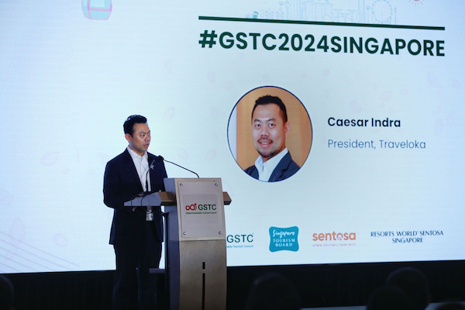“Time has shown that GSTC filled a gap by making available a system that can serve both the private and the public sector to achieve higher levels of sustainability. Our role in establishing and managing global standards is now widely recognized,” said Mr. Cabrini. (Full speech can be found [here](https://www.gstcouncil.org/wp-content/uploads/Luigi-Cabrini-GSTC2024Singapore.pdf))

**Caesar Indra**, **President of Traveloka and GSTC’s Platinum Sponsor,** delivered the keynote address, emphasizing the need for collective action in sustainable tourism. "Building a sustainable tourism movement requires commitment from all of us, from governments setting the standards to businesses that innovate and lead," said Indra. "Today, we see travellers actively choose companies that prioritize community and environment, and our industry must rise to meet this demand. Through collaborations with partners like GSTC, we’ve been working to make thoughtful travel choices more accessible, protecting the destinations we all cherish."

The conference was held at Resorts World Sentosa, the first destination in the world certified to both the [GSTC Destination Criteria](https://www.gstcouncil.org/gstc-criteria/gstc-destination-criteria/) and [GSTC Industry Criteria for Hotels](https://www.gstcouncil.org/gstc-criteria/gstc-industry-criteria/) in 2021. The venue, Equarius Hotel, is also certified to the [GSTC Industry Criteria for Hotels](https://www.gstcouncil.org/gstc-criteria/gstc-industry-criteria/), further enhancing the credentials of the event’s setting.

The Conference offered a rich [agenda](https://www.gstcouncil.org/gstc2024singapore/program/) featuring [pre-conference training](https://www.gstcouncil.org/gstc2024singapore-pre-conference-training/), interactive panels, workshops, meetings, and networking opportunities, as well as tailored [conference tours](https://www.gstcouncil.org/gstc2024singapore/post-conference-tour/) which delegates could sign up for.

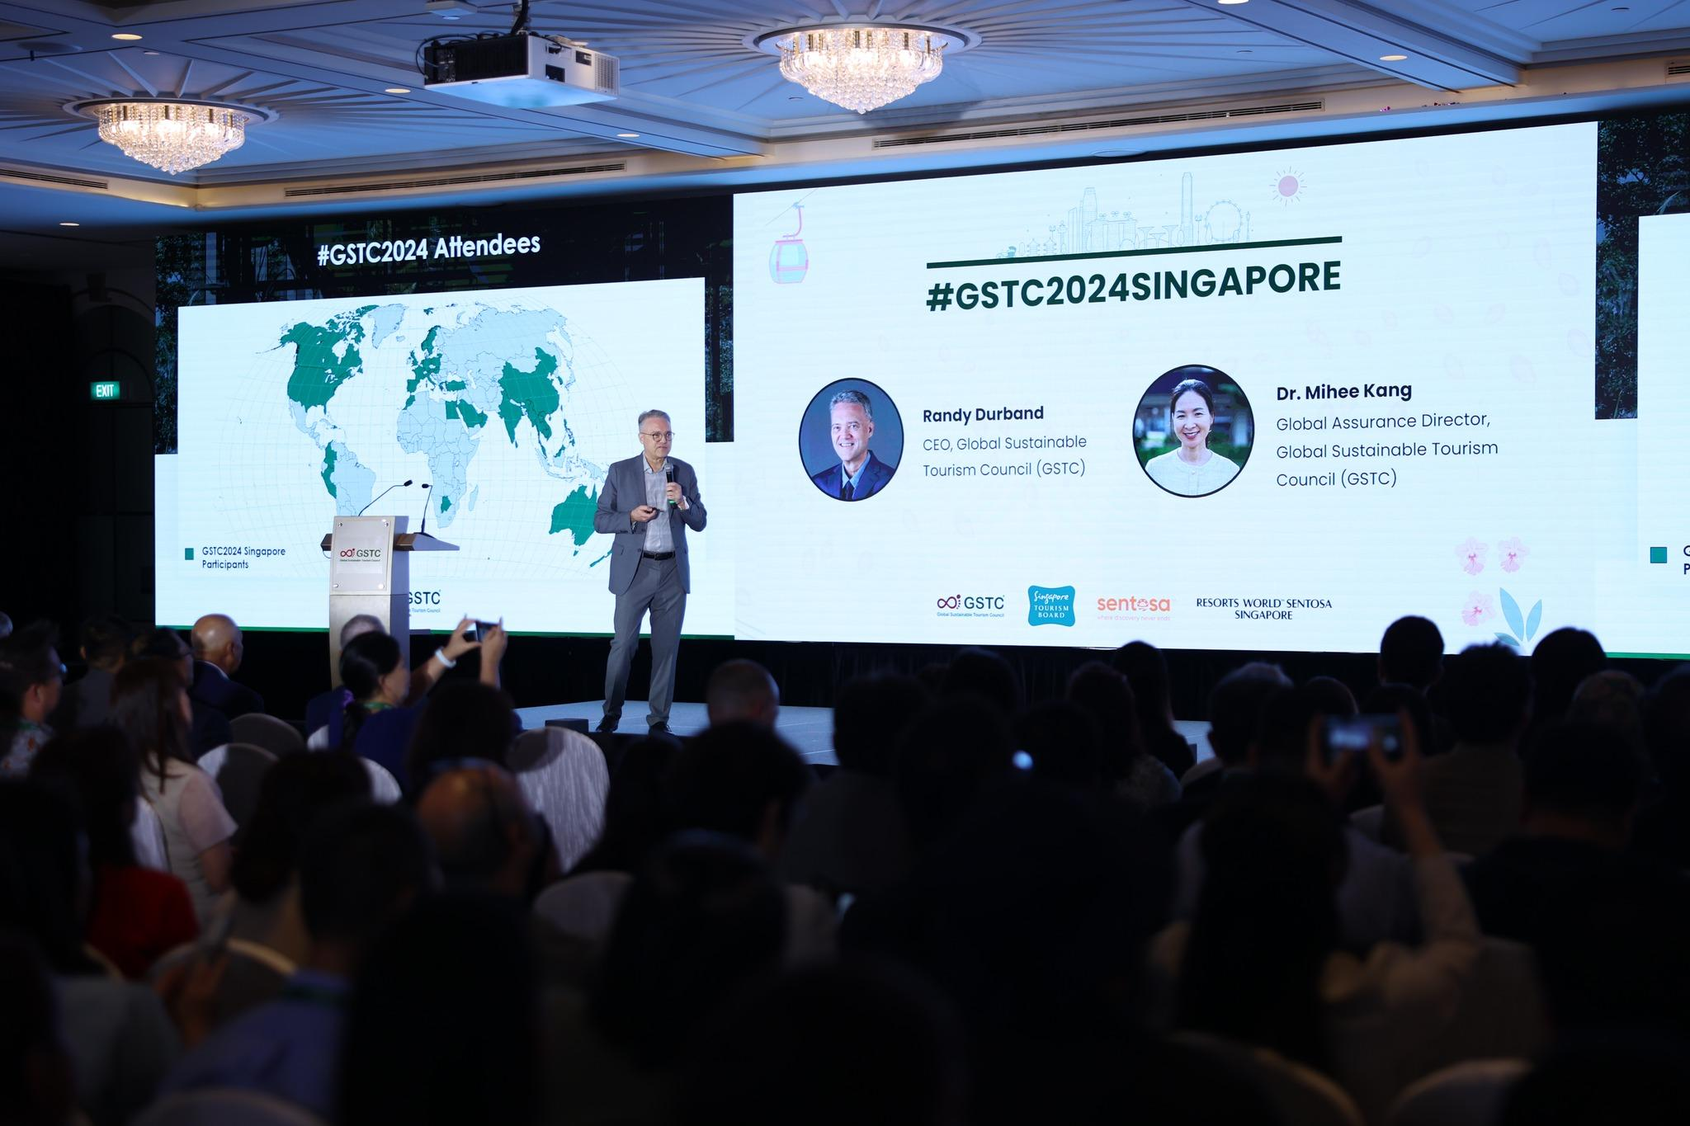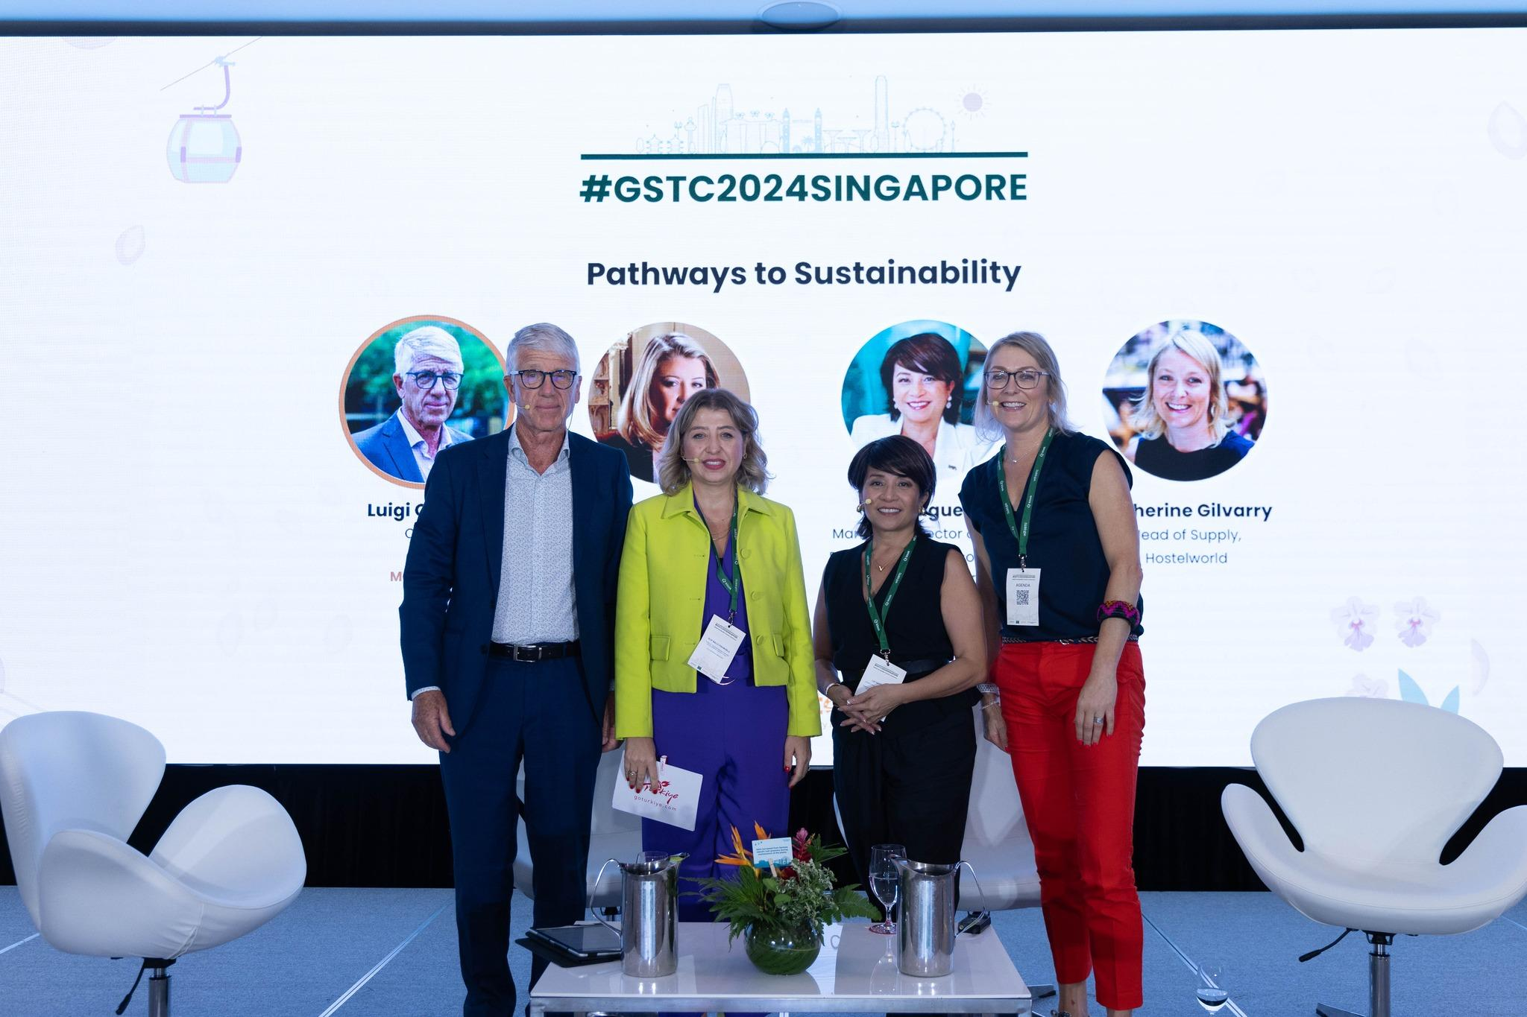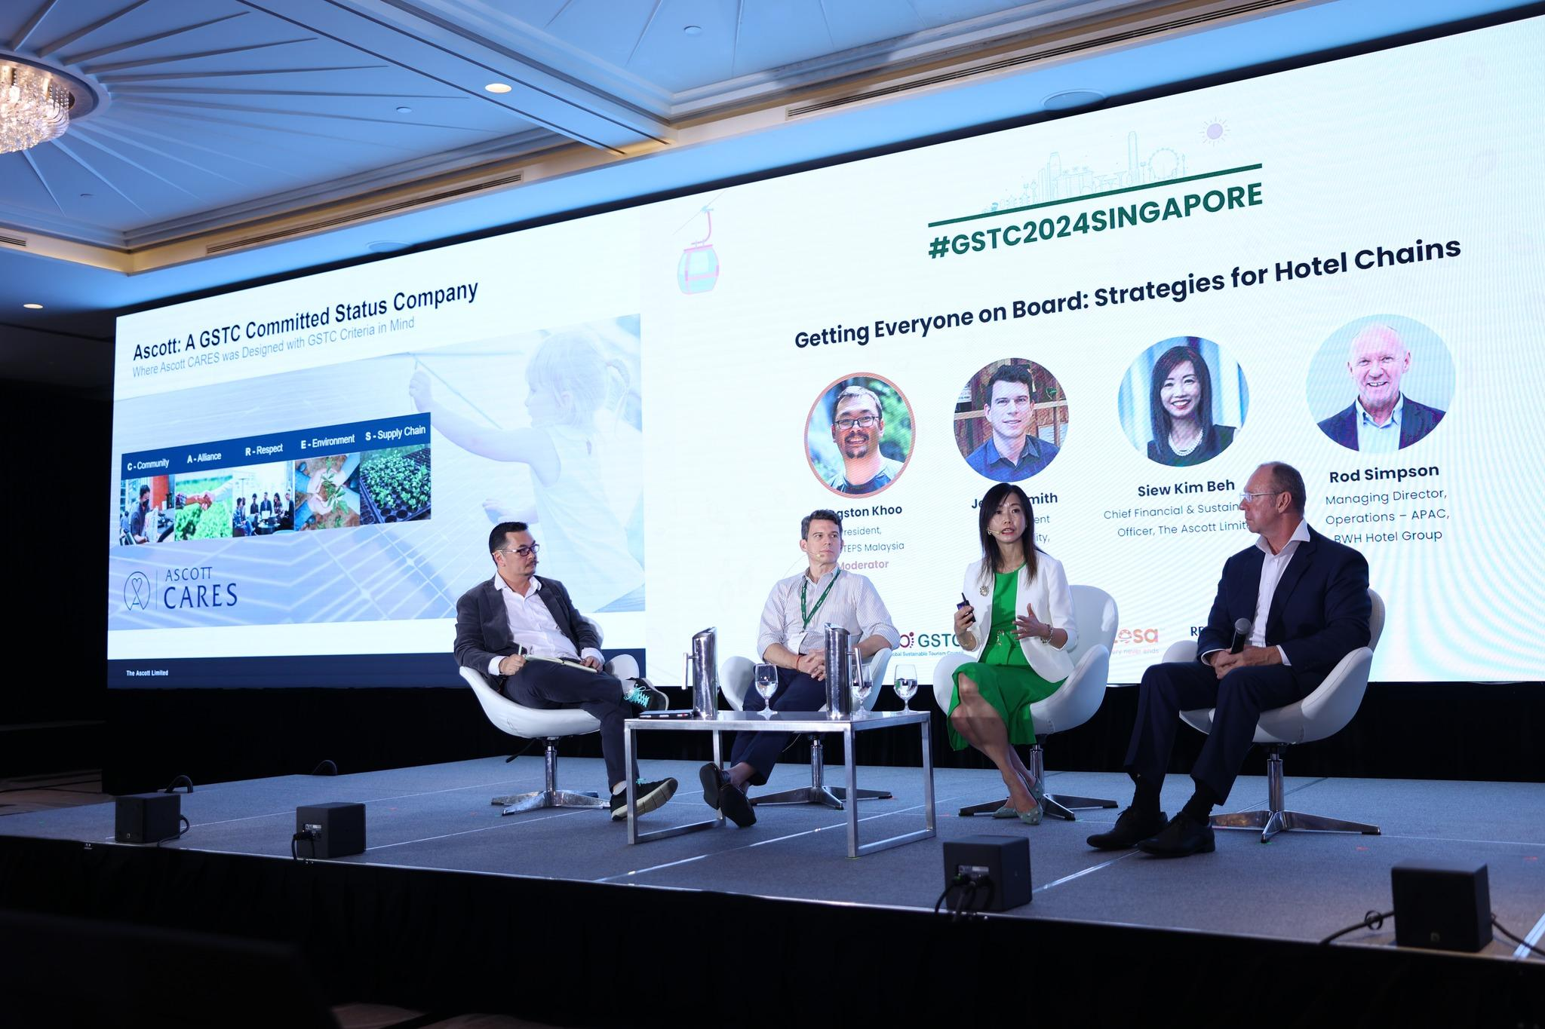

**Ms Lee Shi Ruh**, **President**, **Resorts World Sentosa**, said: “We are extremely honored to host and welcome some 500 delegates to the inaugural GSTC Conference in Singapore at Equarius Hotel, one of our certified hotels at Resorts World Sentosa. This conference allows us to lead sustainability conversations on a global platform with some of the most influential industry leaders in sustainability, to show that sustainable tourism and responsible growth in the hospitality sector can take place in tandem.”

The conference was held at the Equarius Hotel, which is certified against [GSTC Industry Criteria for Hotels](https://www.gstcouncil.org/gstc-criteria/gstc-industry-criteria/). The hotel is located within Resorts World Sentosa, the first destination in the world certified to both the [GSTC Destination Criteria](https://www.gstcouncil.org/gstc-criteria/gstc-destination-criteria/) and [GSTC Industry Criteria for Hotels](https://www.gstcouncil.org/gstc-criteria/gstc-industry-criteria/) 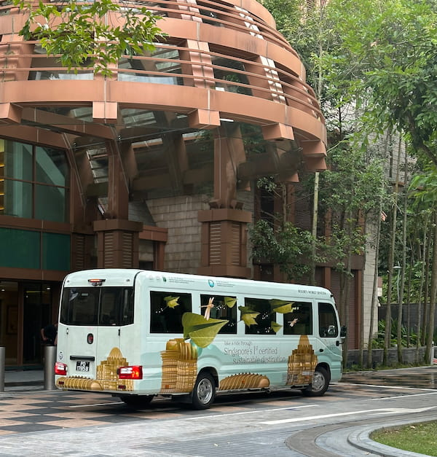in 2021. Additionally, both Sentosa and Singapore are also certified as sustainable destinations, further enhancing the credentials of the event’s setting.

The Conference offered a rich [agenda](https://www.gstcouncil.org/gstc2024singapore/program/) featuring [pre-conference training](https://www.gstcouncil.org/gstc2024singapore-pre-conference-training/), interactive panels, workshops, meetings, and networking opportunities, as well as tailored [post-conference tours](https://www.gstcouncil.org/gstc2024singapore/post-conference-tour/).

During the Conference, several workshops were carried out as the [GSTC Industry Criteria Consultation](https://www.gstcouncil.org/gstc-industry-criteria-revision-second-public-consultation-now-open/) and the GSTC F&B Criteria Consultation.

Prior to the conference, four onsite **GSTC Trainings** took place in Sentosa: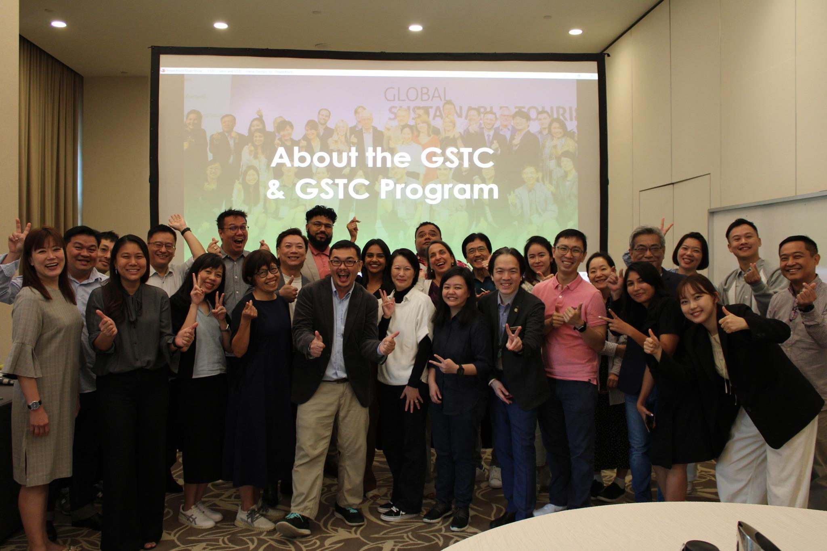

* **GSTC Sustainable Tourism Course for Industry Professionals**, the training specifically focused on the [GSTC Criteria](https://www.gstcouncil.org/gstc-criteria/), the global standards for sustainability in tourism and travel.
* **GSTC Accessible and Inclusive Travel Course**, designed to empower participants with essential knowledge and skills to tap into the thriving accessible and inclusive travel and provide best practices in diversity, equity and inclusion (DEI).
* and **GSTC Auditor Training**, which covered the GSTC Industry Criteria, the audit process, and key issues auditors needed to be aware of.

A total of 80 industry professionals joined the training from across Singapore and globally. Using the [GSTC Industry Criteria](https://www.gstcouncil.org/gstc-criteria/gstc-industry-criteria/) and [GSTC Destination Criteria](https://www.gstcouncil.org/gstc-criteria/gstc-destination-criteria/) as the foundation, the training classes covered various topics relevant to our industry and the sustainability challenges and opportunities we are facing today.

### Recordings of the conference’s plenary sessions can be found on the [GSTC Facebook page](https://www.facebook.com/GlobalSustainableTourismCouncil/) along with photographs of the event. Presentations of the different sessions can be found soon on our [website](https://www.gstcouncil.org/gstc2024singapore/program/).

### Sustainable Practices during the Conference

As with previous GSTC Conferences, the carbon footprint of the event and the travel of all attendees have been calculated, and offset by [Green Evolution](https://green-evolution.eu/). Alongside this, other innovative practices were adopted to minimize waste and environmental impact, showcasing how events can lead by example in sustainability.

**Key initiatives included:**

**- Reduction in Paper and Plastic Usage:** Printing was kept to a minimum, with conference badges made of recyclable TESLIN material instead of traditional plastic coverings. No single-use plastic was used during the event, and eco-friendly, biodegradable bamboo lanyards were introduced, offering the same durability as conventional materials.

**- Upcycling and Recycling Programs:** Attendees were encouraged to place used lanyards and badges in designated recycling boxes. These items were later upcycled through a collaboration with Cloop, a circular fashion textile enterprise. Lobster clasps were repurposed for T-shirt Yarn Wristlet Workshops, and fabric scraps were used as stuffing in their Fabric Ornament Workshops. At the Welcome Dinner at ONE15 Marina, reusable food tag labels were creatively hand-drawn to eliminate the need for printed menu placards.

**- Sustainable Backdrop Materials:** Registration areas utilized durable cardboard furniture that is foldable and compact, ensuring reusability across multiple events. The event backdrop was fabricated using sustainable materials such as honeycomb cardboard and PVC-free banner prints. After the event, materials were sorted and sent for recycling.

**- Digitization to Replace Physical Materials:** Multiple elements of the event were digitized, including registration processes, LED walls, and digital signages, reducing reliance on foam boards and printed materials.

The **Singapore Tourism Board (STB)** extended a complimentary e-card for spending in Singapore for participants who choose to carbon offset their flights individually. By offering this benefit, STB supports both responsible tourism and the local economy, providing travelers with an opportunity to explore Singapore while making a positive environmental impact.

These sustainable practices not only demonstrated a commitment to reducing the conference’s environmental impact but also inspired attendees to adopt similar approaches in their own endeavors. Together, these efforts highlighted GSTC’s ongoing dedication to sustainability and innovation.

### Acknowledgments

Our deep gratitude to all of those who have participated in making this event possible: [Singapore Tourism Board (STB)](https://www.stb.gov.sg/content/stb/en.html), [Sentosa Development Corporation (SDC)](https://www.sentosa.gov.sg/), [Resort World Sentosa (RWS)](https://www.rwsentosa.com/en) and [One 15 Marina Sentosa Cove Singapore](https://one15marina.com/), [Village Hotel Sentosa](https://www.villagehotels.asia/en/hotels/village-hotel-sentosa) and the event partner [Unearth Productions (UP)](https://www.traveloka.com/en-en).

Our Exhibitors at the event were [Peterson](https://www.onepeterson.com/), [Control Union](https://www.controlunion.com/office/control-union-singapore-pte-ltd/), [Greenview](https://greenview.sg/), [Tüv Rheinland](https://www.tuv.com/thailand/en/), [Traveloka](https://www.traveloka.com/en-en), [Tourism Fiji](https://www.fiji.travel/), [Signify](https://www.signify.com/nl-nl?origin=&gad_source=1&gclid=Cj0KCQiAire5BhCNARIsAM53K1hrInpqDgIXK8myV8HNyXyyPKPOACWi4Tmg9B7lj8Zowvgg4iUdJM4aAjOQEALw_wcB&gclsrc=aw.ds), and [Union of Kansai Governments](https://www.kouiki-kansai.jp/).

Our Media Partners were [DestinAsia](https://destinasian.com/), [Asia Sustainable Travel (AST](https://www.asiasustainabletravel.com/)), [Hotel Jolt](https://www.hoteljolt.com), [Sustainable Hotel News](https://sustainablehotelnews.com/), [Travel Weekly Asia](https://www.travelweekly-asia.com/) and [M&C Asia](https://www.meetings-conventions-asia.com/) which we want to thank for their support in spreading the news about the Conference.

As well as all the other event sponsors such as [Booking.com](http://booking.com) and [Klook](https://www.klook.com/) and **GSTC’s Gold Sponsors** [Türkiye Tourism Promotion and Development Agency (TGA)](https://tga.gov.tr/), [Tourism Fiji](https://www.fiji.travel/) and [Visit Sweden](https://visitsweden.com/) for their continued support.

Special thanks to **GSTC’s Platinum Sponsor**, [Traveloka](https://www.traveloka.com/en-en), for their outstanding commitment to promoting sustainable tourism and fostering positive change within the industry. Your dedication and partnership are invaluable in driving forward our mission for a more sustainable future for all.

Thank you all for making an unforgettable #GSTC2024 in Sentosa, Singapore.

For updates about future conferences and other important developments, [sign up for the GSTC monthly newsletter](https://www.gstcouncil.org/mailing-list-subscription/).

## **Upcoming GSTC2025 and GSTC2026 Global Conferences**

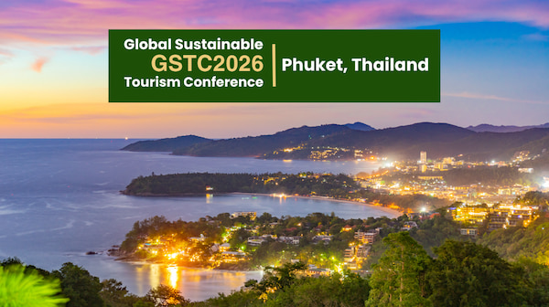

At the closing ceremony, the next GSTC Conferences were announced – #GSTC2025 Fiji (5th to 8th August 2025), and #GSTC2026 Phuket. You can Register your interest [here](http://eepurl.com/i0Dlh2) to be informed when early-bird registration opens for #GSTC2025.

*[Top photo from left to right: Lee Cheh Hsien - SDC ACEO, Randy Durband - GSTC CEO, Thien Kwee Eng - SDC CEO, Luigi Cabrini - GSTC Chair, Alvin Tan - Minister of State, Ministry of Trade and Industry & Ministry of Culture, Community and Youth, Bob Tan - SDC Chair, Ong Huey Hong - STB ACEO, Tan Hee Teck - RWS CEO]*

**#END#**