GSTC to Develop New GSTC Criteria for Food Service Providers in Tourism

The **Global Sustainable Tourism Council (GSTC)**, with support from the Türkiye Tourism Promotion and Development Agency (TGA), is further developing the GSTC Criteria, the global standards for sustainable tourism, with a new set for tourism food service providers (official name to be determined during the development process). This new set of GSTC Criteria will serve as the industry's global sustainability standards for tourism-related food service providers.

The name of these Criteria will be decided during the development of the Criteria.

Food and beverages are essential components of a destination’s intangible heritage and tourism offerings. With increasing demand, gastronomy tourism generates significant revenue and boosts employment in various locations. However, this industry can also adversely affect the environment, local communities, and cultural heritage.

Development of the new GSTC Criteria

Given the ever-growing size of gastronomy tourism and the increasing demand for sustainable tourism, there is a need for global guidelines that inform sustainable practices that restaurants must follow. The **GSTC Criteria** will allow industry players to manage their kitchens and dining facilities and services more sustainably, understand the basic elements for reducing costs by implementing sustainability policies and practices, and safeguard the ecosystems, biodiversity, wildlife, culture, and local economies.

The GSTC is committed to ensuring that best practices for sustainable tourism are adopted and implemented by the industry, destinations, and travelers. With the development of the new Criteria, the GSTC will add a new training program related to sustainability in restaurants and tourism food service providers, expanding its renowned [Sustainable Tourism Training Program](https://www.gstcouncil.org/sustainable-tourism-training/).

“All of the specific sets of GSTC Criteria are widely regarded as ‘the global standards for sustainable tourism’ due to our highly inclusive process of developing them and because their foundation is UN-developed and compatible with the SDGs,” says **GSTC CEO Randy Durband**.

The application of these GSTC Criteria will have a long-term impact, as their continued use can significantly reduce negative environmental impacts, preserve local cultures and cuisines, and support sustainable consumption and production patterns.

Moreover, food sustainability is closely linked to the UN Sustainable Development Goals, particularly Goal 2 (Zero Hunger), Goal 3 (Good Health and Well-being), Goal 12 (Sustainable Consumption and Production Patterns), Goal 14 (Life Below Water), and Goal 15 (Life on Land).

### Criteria Development Process

During the Criteria development, a Criteria Development Advisory Group composed of up to 10 organizations from both public and private sectors will be formed. The main objective of this group is to offer their expert opinion and comments to the GSTC Technical Team while GSTC will retain full oversight and control of the Criteria development process. The Advisory Group will also encourage the restaurant industry to participate in the Public Consultation and Feasibility Assessment phases of the Criteria Development process.

The GSTC's International Standards Committee (ISC) will oversee the entire development and revision process. The development and content of the ‘Terms of Reference’ (TOR) endeavor to comply with the requirements of the ISEAL Standard-Setting Code of Good Practice.

This also includes online and in-person public consultations, of which one public consultation workshop will be held at the [**GSTC2024 Conference in Singapore**](https://www.gstcouncil.org/gstc2024singapore/) (November 13-16, 2024).

More detailed information about the process is available in the new GSTC Criteria Development Terms of Reference (TOR) document [here](https://www.gstcouncil.org/wp-content/uploads/GSTC-Criteria-for-Food-Service-Providers-in-Tourism_TOR.pdf).

A visual for the Criteria development process is shown below (Figure 1).

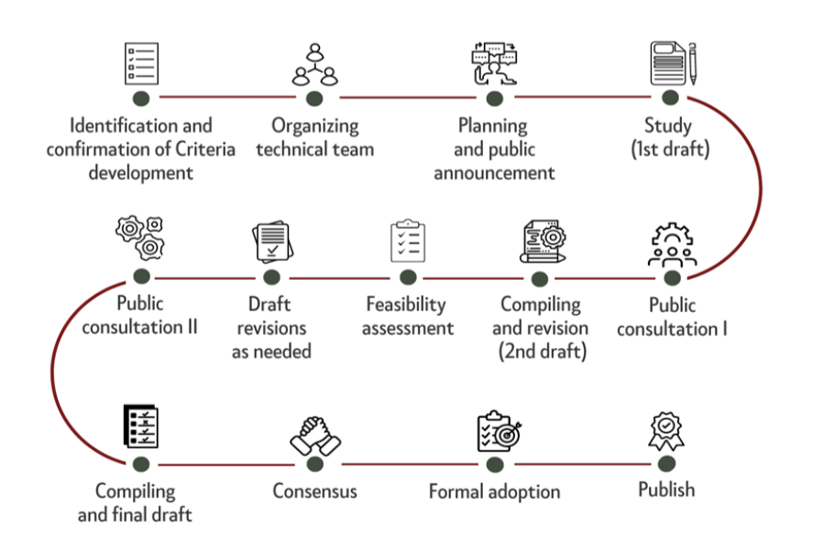

### Key contributor - Türkiye Tourism Promotion and Development Agency (TGA)

Following Türkiye’s success in the implementation of its [National Sustainable Tourism Program](https://www.gstcouncil.org/turkiye-national-sustainable-tourism-program/), which was launched in 2022 in collaboration with GSTC, to accelerate sustainable practices in the Turkish tourism industry, TGA is demonstrating its commitment to sustainability by contributing to GSTC’s global efforts in driving sustainable tourism in the F&B sector.

Highlighting that Türkiye was the first country to make an agreement with the Global Sustainable Tourism Council (GSTC) at the Governmental level in 2022, **Republic of Turkiye Minister of Culture and Tourism Mehmet Nuri Ersoy** said: “So far, we have verified and certified over 18,000 accommodation facilities under the ‘Türkiye’s Sustainable Tourism Program,’ prepared as part of this agreement. Following this success in the accommodation sector, we launch the next phase of our Sustainable Tourism Program, expanding our efforts to include the food and beverage sector. The certification program we will implement for the food and beverage sector, which will pioneer the world once again, demonstrates the continuity of our sustainability efforts in tourism while also increasing the number of our businesses providing services in line with GSTC criteria in the field of gastronomy. With this program, which will be in harmony with our culinary culture that inherently embraces the concept of sustainability, we will continue to be an exemplary country in sustainable tourism worldwide.”

Türkiye’s Pilot Certification Test

The TGA will be launching a pilot certification program under the National Sustainable Tourism Program. This program will apply the criteria from the GSTC Industry Criteria and the revised indicators to assess the feasibility of certifying restaurants.

### About the GSTC

The Global Sustainable Tourism Council® (GSTC®) establishes and manages global sustainable standards, known as the GSTC Criteria. There are three sets: [Destination Criteria](https://www.gstcouncil.org/gstc-criteria/gstc-destination-criteria/) for public policy-makers and destination managers, [Industry Criteria](https://www.gstcouncil.org/gstc-criteria/gstc-industry-criteria/) for Hotels and Tour Operators, and [MICE Criteria](https://www.gstcouncil.org/gstc-criteria/gstc-mice-criteria/) for Venues, Event Organizers, and Events & Exhibitions. These are the guiding principles and minimum requirements that any tourism business or destination should aspire to reach in order to protect and sustain the world’s natural and cultural resources while ensuring tourism meets its potential as a tool for conservation and poverty alleviation.

The GSTC Criteria form the foundation for GSTC’s assurance role for Certification Bodies that certify hotels/accommodations, tour operators, and destinations as having sustainable policies and practices in place. GSTC does not directly certify any products or services, but provides accreditation to those that do. The GSTC is an independent and neutral USA-registered 501(c)3 non-profit organization that represents a [diverse and global membership](https://www.gstcouncil.org/membership/member-search/), including national and provincial governments, leading travel companies, hotels, tour operators, NGOs, individuals and communities – all striving to achieve best practices in sustainable tourism.

Information for media and the press: [www.gstcouncil.org/about/for-the-press/](http://www.gstcouncil.org/about/for-the-press/)

### About Türkiye Tourism Promotion and Development Agency

Founded on July 15, 2019, Türkiye Tourism Promotion and Development Agency (TGA) is dedicated to delivering Türkiye as a brand and a popular destination in both domestic and international tourism markets; discover, develop and promote tangible and intangible natural, cultural, biological and manmade heritage assets; boost the tourism capacity of Türkiye, increase the rate of tourism investments in the national economy and raise the quality of service with short, medium and long term communication and marketing activities.

In line with tourism strategies and policies set by the Ministry of Culture and Tourism, the Agency will carry out all promotion, marketing and communication activities to serve Türkiye’s tourism goals, promote and market current tourism opportunities across the globe as well as discover, improve and establish potential areas of tourism. Operating under the auspices of the Ministry of Culture and Tourism, the Agency is subject to private law provisions.

More information here: <https://tga.gov.tr/en>

**#END#**

**Image:**

