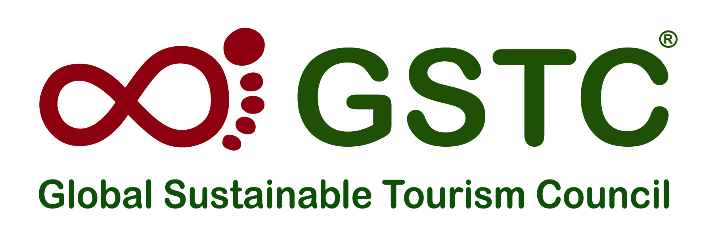

**GSTC Partners with WTTC to Strengthen**

**Global Hospitality Standards**

**The Global Sustainable Tourism Council (GSTC)** and **The World Travel & Tourism Council (WTTC)** announce a major new partnership, aligning to establish a structured framework for hotel sustainability, leading to [GSTC Certification.](https://www.gstcouncil.org/certification/become-certified-hotel/)

The partnership endorses the existing [**WTTC Hotel Sustainability Basics**](https://wttc.org/initiatives/hotel-sustainability-basics) whilst paving the way for a stepped progression toward GSTC Certification* for sustainable hotels.

In an era where sustainability is paramount, GSTC and WTTC are joining forces to send a potent message to the market regarding the coherence and collaboration in the Travel & Tourism sector.

The three-stage framework for hotel sustainability will now see the integration between the WTTC Hotel Sustainability Basics verification and GSTC Certification*, designed to support hotels in their pathway towards full sustainability.

**Julia Simpson, WTTC President & CEO,** said: “Collaborating with an esteemed body like GSTC reinforces our dedication to leading the industry towards a more sustainable future. It's imperative that we work with key global players like GSTC to drive change, set benchmarks, and inspire others to follow.

With members spanning across the world, GSTC's rigorous accreditation program not only elevates our initiative but also ensures that the hospitality sector worldwide moves toward a unified vision of sustainability.”

**Randy Durband, CEO of GSTC**, added, “WTTC Hotel Sustainability Basics is a finely crafted entry level for hotels of any size and type to begin their journey to sustainable practices. GSTC’s certification by GSTC-Accredited Certification Bodies is recognised widely as the gold standard in certification of sustainable hotels, with the highest levels of assurance that exists.

Today’s announcement of the combined pathway provides clarity for beginning and for continuous improvement. Stages must be just that, stages, and not levels to reach and stay in place.”

The WTTC Hotel Sustainability Basics are already accessible to the industry, and the next phase in collaboration with GSTC is scheduled to launch in 2024.

This will provide the crucial stepping stone between WTTC Hotel Sustainability Basics, a three-year programme, and GSTC’s rigorous certification, ensuring a gradual yet comprehensive progression towards sustainability in hospitality.

*Note: The term ‘GSTC Certification’ is used as shorthand for ‘Certified by a Certification Body that is GSTC-Accredited’*

**#END#**

Image:

