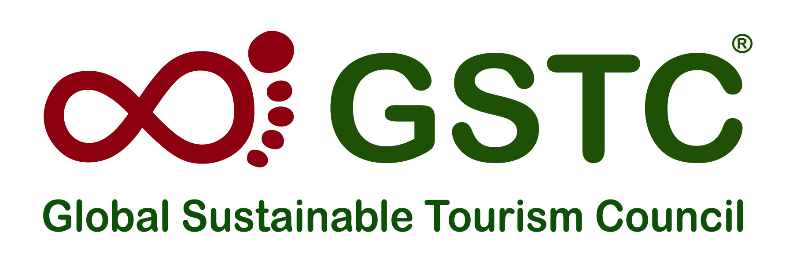

GSTC Attraction Criteria

1st Public Consultation is Now Open

The Global Sustainable Tourism Council® (GSTC®) announced in April 2023 the development of new criteria sets, GSTC MICE Criteria and GSTC Attraction Criteria, with support from the Singapore Tourism Board STB.

The GSTC MICE Criteria (covering Venues, Event Organizers, and Events/Exhibitions) and GSTC Attraction Criteria aim to serve as the global sustainability standards for these respective industries.

The first public consultation period for the GSTC Attraction Criteria has begun and will remain open until the 15th of March, 2024 (60 days). Professionals and practitioners in the attraction sector are invited to share insights during the first public consultation phase of the GSTC Attraction Criteria.

The GSTC Attraction Criteria includes four sections: Section A (Demonstrate effective sustainable management); Section B (Maximize social and economic benefits to the local community and minimize negative impacts); Section C (Maximize benefits to cultural heritage and minimize negative impacts) and Section D (Maximize benefits to the environment and minimize negative impacts).

You are more than welcome to make your comments on the whole criteria set here: https://www.surveymonkey.com/r/9N7FKRT

Or if you would like to comment on one specific section that you feel most confident, please click on the links below:
- GSTC Attraction Criteria section A: Demonstrate effective sustainable management
- GSTC Attraction Criteria section B: Maximize social and economic benefits to the local community and minimize negative impacts
- GSTC Attraction Criteria section C: Maximize benefits to cultural heritage and minimize negative impacts
- GSTC Attraction Criteria section D: Maximize benefits to the environment and minimize negative impacts
Please share this invitation with anyone you know who is involved with tourist attractions and sustainability. This could include theme parks, museums, attractions, national parks, tour operators, travel agents, hotel owners, event planners, policymakers, academics, non-profits, community members, or even individual travelers.
After the first public consultation period is over, a compiling and revision will be made which will be reviewed during the feasibility assessment followed by drafting revisions as needed.
Participants at the GSTC2024 Conference in Stockholm, Sweden, from April 23-26, will have the opportunity to participate in an in-person consultation workshop about the GSTC Attraction Criteria.
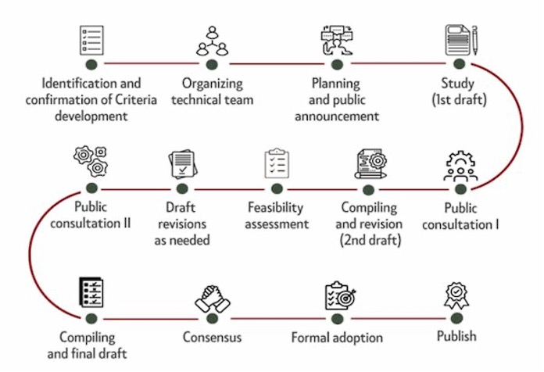
More detailed information about the process is available here: GSTC Attraction Criteria Development Terms of Reference (TOR) document.

The current Attraction Criteria Development Advisory Group includes the following organizations: Singapore Tourism Board, Association of Singapore Attractions (ASA), The Global Association for the Attractions Industry (IAAPA), South African Tourism Services Association (SATSA), The Royal Djurgården Society, and U.S. National Park Service.
To know more about GSTC Criteria Development, Feedback, and Revision, please check this page.
#END#

About the GSTC
The Global Sustainable Tourism Council® (GSTC®) establishes and manages global sustainable standards, known as the GSTC Criteria. There are two sets: Destination Criteria for public policy-makers and destination managers, and Industry Criteria for hotels and tour operators. These are the guiding principles and minimum requirements that any tourism business or destination should aspire to reach in order to protect and sustain the world’s natural and cultural resources, while ensuring tourism meets its potential as a tool for conservation and poverty alleviation.
The GSTC Criteria form the foundation for Accreditation of Certification Bodies that certify hotels/accommodations, tour operators, and destinations as having sustainable policies and practices in place. GSTC does not directly certify any products or services; but it accredits those that do. The GSTC is an independent and neutral USA-registered 501(c)3 non-profit organization that represents a diverse and global membership, including national and provincial governments, leading travel companies, hotels, tour operators, NGO’s, individuals and communities – all striving to achieve best practices in sustainable tourism.
Information for media and the press: https://www.gstcouncil.org/about/for-the-press/

Images:

