**Mauritius Standards Bureau (MSB) is now GSTC-Accredited**

August 14, 2023 – The Global Sustainable Tourism Council (GSTC) is pleased to announce that Mauritius Standards Bureau (MSB) has gained the GSTC-Accredited Certification Body status. 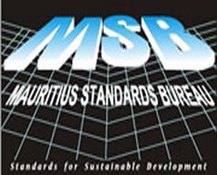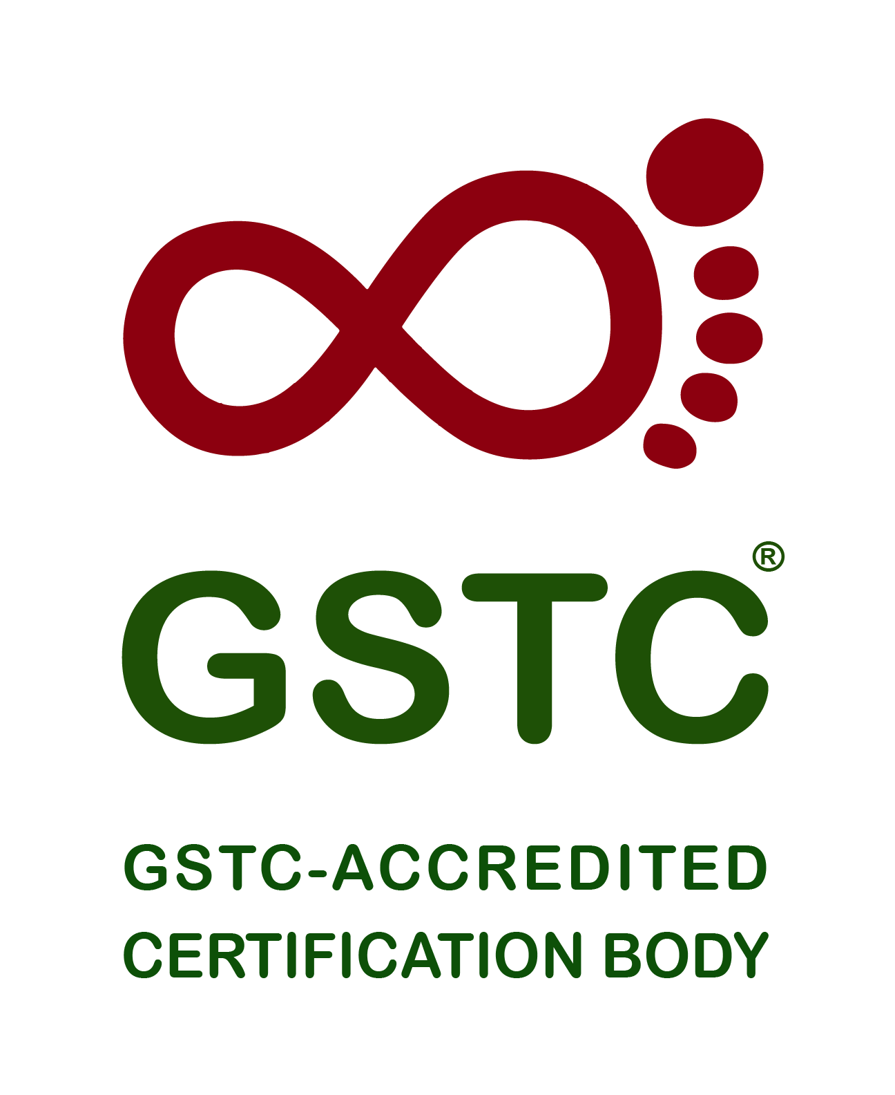

The Mauritius Standards Bureau (MSB), a non-profit parastatal body in the island of Mauritius, has embarked on a project to provide third-party certification to tourism businesses with the aim of boosting the local tourism industry towards sustainability.

After having developed its own Mauritian Standard (MS 165:2019) for Sustainable Tourism, which has gained [recognition from the GSTC in 2019](https://www.gstcouncil.org/the-mauritian-standard-on-sustainable-tourism-is-gstc-recognized/), MSB has successfully completed all the steps towards accreditation.

The stated scope of the GSTC Accreditation of Mauritius Standards Bureau is for certifying hotels/accommodations and tour operators in Mauritius according to the [Mauritian Standard on Sustainable Tourism: Blue Oasis (MS 165:2019)](https://www.gstcouncil.org/the-mauritian-standard-on-sustainable-tourism-is-gstc-recognized/).

Achieving the **GSTC-Accredited status** means that a Certification Body has been verified to be conducting proper certification of businesses, such as hotels or tour operators, in a competent and neutral manner, following processes and procedures detailed in the GSTC Accreditation Manual.

Businesses certified by a GSTC-Accredited Certification Body, meeting all the GSTC Criteria (or a GSTC-Recognized Standard), have the **highest level of assurance**\* and credibility available. With an accredited certification, customers and buyers are assured that the business was certified in a credibly verified procedure in a transparent, impartial, and competent manner.

Attesting to that, those businesses certified by a GSTC-Accredited Certification Body can display a unique GSTC logo with a traceable code. The purpose of the GSTC Accreditation is to provide a higher level of assurance and reward genuine practitioners of sustainable tourism, which builds confidence and credibility with consumers.

The Accreditation process usually takes more than a year to complete, as GSTC looks very hard at the Certification Body’s operation and its process of certification to assure that they issue certifications based on merit and neutrality.

“Mauritius is one of the Small Island Developing States (SIDS) which suffers directly from impacts of climate change. Therefore, it is crucial for us to gear towards Sustainable Development. Tourism is a major pillar of our economy and through Sustainable Tourism we are considerably addressing socio-cultural, economic and environmental impacts.

This accreditation shows that the Mauritius Standards Bureau has achieved international affirmation for providing third-party certification for Sustainable Tourism to the local Hotels/Accommodations and Tour Operators. It is a major step towards the ultimate goal of making Mauritius a sustainable destination for tourism.” says **M Yusuf Foondun, Officer-in-Charge of MSB**.

The GSTC Accreditation Manual for Certification of Hotel/Accommodation & Tour Operator provides detailed technical requirements for certification of Hotel/Accommodation and Tour Operator. Certification Bodies are required to comply with ISO 17065 Conformity Assessment (Requirements for bodies certifying products, processes and services) and GSTC specific requirements. Among these requirements are impartial and competent certification procedures, auditor experience and qualifications, certification decision making, rigorous surveillance of certified businesses, and proper promotion of their services.

“GTSC Accreditation is a mark of quality that the GSTC places on Certification Bodies that choose to provide formal evidence of compliance to the GSTC Accreditation Manual for rigorous and impartial certification. We congratulate MSB’s commitment to maintaining the highest standards of fairness and quality. With this accreditation, theirs is the first national program to gain such accreditation and join a select group of Certification Bodies who have reached such a pinnacle of achievement," says **Randy Durband, CEO of GSTC.**

**Hotels** that follow sustainability standards that wish to stand out with reputable certification as a sustainable hotel, should seek [sustainable hotel certification by a GSTC-Accredited Certification Body](https://www.gstcouncil.org/certification/become-certified-hotel/).

**Tour Operators** that want to demonstrate through their adherence to sustainability standards are encouraged to seek [sustainable tour operator certification by a GSTC-Accredited Certification Body](https://www.gstcouncil.org/certification/become-certified-tour-operator/).

**Destinations** that are managed in accordance with sustainability standards can aim for [destination certification by one of the GSTC-Accredited Certification Body](https://www.gstcouncil.org/certification/become-certified-destination/)

**About the Global Sustainable Tourism Council (GSTC)**

The Global Sustainable Tourism Council® (GSTC®) establishes and manages global sustainable standards, known as the GSTC Criteria. There are two sets: [Destination Criteria](https://www.gstcouncil.org/gstc-criteria/gstc-destination-criteria/) for public policy-makers and destination managers, and [Industry Criteria](https://www.gstcouncil.org/gstc-criteria/gstc-industry-criteria/) for hotels and tour operators.

The GSTC Criteria form the foundation for Accreditation of Certification Bodies that certify hotels/accommodations, tour operators, and destinations as having sustainable policies and practices in place. GSTC does not directly certify any products or services; but it accredits those that do. The GSTC is an independent and neutral USA-registered 501(c)3 non-profit organization that represents a [diverse and global membership](https://www.gstcouncil.org/membership/member-search/), including national and provincial governments, leading travel companies, hotels, tour operators, NGO’s, individuals and communities – all striving to achieve best practices in sustainable tourism.

Information for media and the press: <https://www.gstcouncil.org/about/for-the-press/>

**About MSB**

The Mauritius Standards Bureau is an integral part of the Mauritian Quality Infrastructure. It is a parastatal body operating under the aegis of the Ministry of Industrial Development, SMEs and Cooperatives. It was created in 1975 with the mandate to develop national standards and provide conformity assessment services. The overriding focus of MSB is to spearhead industrial development and the economic growth of Mauritius through the timely delivery of Metrology, Standards, Testing and Quality Assurance services.

MSB develops Mauritian Standards based on Annex 3 to the WTO/TBT Agreement: Code of Good Practice for the Preparation, Adoption and Application of Standards. Its laboratory management systems are accredited to ISO/IEC 17025 whereas its management systems certification is accredited to ISO/IEC 17021. These accreditations provide recognition that its services are offered in line with international best practices.

Further information available on [https://msb.intnet.mu](https://msb.intnet.mu/)

Contacts:

Mr Naushad LUTTOO

(Manager - Quality Assurance Unit)

email:[**nluttoo@msb.intnet.mu**](mailto:nluttoo@msb.intnet.mu)

Mr Saminaden Pillay KANAKSABEE

(Head of Quality Assurance Unit)

email:[**skanaksabee@msb.intnet.mu**](mailto:skanaksabee@msb.intnet.mu)

Mr M Yusuf Foondun

(Officer in Charge - MSB)

email: [**MYFoondun@msb.intnet.mu**](mailto:MYFoondun@msb.intnet.mu)

—-

*\* Note: General assurance levels:   
3rd-party certification by an Accredited Certification Body (impartiality is certain)  
3rd-party verification (impartiality is not certain)  
2nd-party verification (not impartial)  
1st-party self-assessment  
No verification at all*

PICTURES

©Photo Credit: Joelmir Barbosa via Canva.com

©Photo Credit: [Mlenny](https://www.canva.com/design/DAFavO6eKZg/rY0CBc4GVxRtTDN4WInnEA/edit) via Canva.com