# #GSTC2023 Global Sustainable Tourism Conference

## The GSTC Sustainable Tourism Conference will be held in Antalya, Türkiye between the 9th - 12th of May 2023

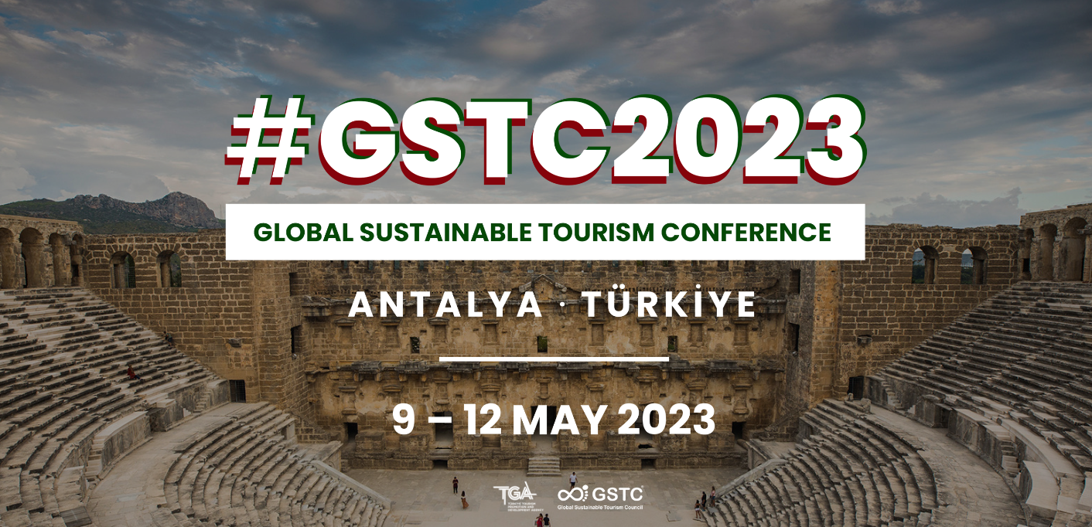

The Global Sustainable Tourism Council (GSTC), which sets global standards for sustainable travel and tourism and manages the implementation of these standards, will hold this year the [GSTC2023 Global Sustainable Tourism Conference](https://www.gstcouncil.org/gstc2023/) in Antalya, Türkiye. The annual global conference – the signature event of GSTC – takes place annually in different countries and brings together tourism stakeholders involved in the development and promotion of sustainable travel and tourism.

The [GSTC2023 Global Sustainable Tourism Conference](https://www.gstcouncil.org/gstc2023/) will host 400 international and local participants in Antalya, including representatives from the public sector, hotels, tour operators, companies, academia, development agencies, online travel agencies, and non-governmental organizations. The four-day conference program includes training, interactive panels and workshops, meetings, and social events. Participants will have the opportunity to benefit from the practical experience of experts in developing and promoting sustainable tourism while enjoying a chance to discover Antalya, Türkiye's travel paradise.

The conference will feature four key themes, including **Destination Stewardship** (1), **Hotel Sustainability** (2), **Sustainable Tours, Experiences, and Attractions** (3), as well as **Sustainable MICE** (4). Each theme will offer valuable insights and practical solutions to promote sustainable practices in tourism, while highlighting the importance of responsible management of natural and cultural resources, supporting local communities, and achieving the Sustainable Development Goals.

Some of the first confirmed speakers include:

* Matt Callaghan, Director of Customer & Operations, easyJet holidays
* Natalie Kidd, Managing Director, Asia, Intrepid / GSTC Board Member
* Minas Papadakis, CEO,Port Authority of Heraklion
* Pegi Amarteifio, VP, Global PR & Communications, Small Luxury Hotels of the World
* Catherine Gilvarry, Head of Supply, Hostelworld
* Arantxa Garcia Lis, Head of Sustainability, TUI Musement, TUI Group
* Figen Ayan, President, MedCruise / Chief Port Officer, Galataport Istanbul

The full list of speakers can be [found here.](https://www.gstcouncil.org/gstc2023/speakers/)

If you are interested in participating, registration is still open here: [www.gstcouncil.org/gstc2023/](https://www.gstcouncil.org/gstc2023/)

Located in the south of Türkiye, in the heart of the Mediterranean and the Turkish Riviera, Antalya is famous for its natural beauty, sea, historical texture, and cultural structure. The city welcomes thousands of tourists annually and stands out with adventure, culture-art and entertainment options in addition to the "sea-sand-sun" trilogy.

The conference series held online for two consecutive years due to the pandemic, took place in Seville, Spain, last year. At the 2022 GSTC Sustainable Tourism Conference, in which Türkiye also participated, it was announced that the 2023 edition would be held in Antalya after the candidacy process carried out by the Turkish Tourism Promotion and Development Agency (TGA). Antalya's hosting was introduced with a video specially prepared for participants, and a panel on the Turkish National Sustainable Tourism Program was organized at the conference. It is available to watch [here](https://www.youtube.com/playlist?list=PLm4B_omiA_xDrE_72-7u-ydi8Guw-3CSY).

**Sustainability in Türkiye**

Through a three-year protocol, the National Sustainable Tourism Program was established to restructure Türkiye's tourism industry, making it the first country to collaborate with the government on sustainable tourism practices, following the cooperation agreement signed with GSTC at the beginning of 2022.

The Program, which includes destinations, tour operators, and especially accommodation facilities, aims for sustainable transformation in Türkiye's tourism industry. Carried out in stages, the first phase of the Program has been operational since the end of 2022; The second stage will be carried out gradually throughout 2025. The program is planned to be concluded by 2030, when all accommodations comply with international standards of sustainable tourism.

#END#

**About the Global Sustainable Tourism Council (GSTC)**

The Global Sustainable Tourism Council® (GSTC®) establishes and manages global sustainable standards, known as the GSTC Criteria. There are two sets: [Destination Criteria](https://www.gstcouncil.org/gstc-criteria/gstc-destination-criteria/) for public policy-makers and destination managers and [Industry Criteria](https://www.gstcouncil.org/gstc-criteria/gstc-industry-criteria/) for hotels and tour operators. These are the guiding principles and minimum requirements that any tourism business or destination should aspire to reach to protect and sustain the world’s natural and cultural resources while ensuring tourism meets its potential as a conservation and poverty alleviation tool.

The GSTC Criteria form the foundation for GSTC’s assurance role for Certification Bodies that certify hotels/accommodations, tour operators, and destinations as having sustainable policies and practices in place. GSTC does not directly certify any products or services but provides accreditation to those that do. The GSTC is an independent and neutral USA-registered 501(c)3 non-profit organization representing a diverse and [global membership](https://www.gstcouncil.org/membership/member-search/), including national and provincial governments, leading travel companies, hotels, tour operators, NGOs, individuals and communities – all striving to achieve the best practices in sustainable tourism.

Information for media and the press: [www.gstcouncil.org/about/for-the-press/](http://www.gstcouncil.org/about/for-the-press/)

**About Türkiye Tourism Promotion and Development Agency (TGA)**

Türkiye Tourism Promotion and Development Agency (TGA) is dedicated to delivering Türkiye as a brand and a popular destination in both domestic and international tourism markets; discover, develop and promote tangible and intangible natural, cultural, biological and manmade heritage assets; boost the tourism capacity of Türkiye, increase the rate of tourism investments in the national economy and raise the quality of service with short, medium and long-term communication and marketing activities.

The Agency is made up of the Board of Directors, Executive Board, and Advisory Board, with the Board of Directors serving as the decision-making body. The Board of Directors comprises of 15 members chaired by the Minister of Culture and Tourism of the Republic of Türkiye. The Executive Board, the executive branch of the Agency, is chaired by the Deputy Minister in charge of the Directorate General of Promotion, with a total of 5 members, 3 of whom named by the Minister among Board of Directors Members and the Director-General.

With a distinguished Board of Directors team considerably experienced in domestic and international tourism, Türkiye Tourism, Promotion and Development Agency will dedicate all efforts to contributing and reinforcing the position Türkiye aims to secure in the international market, brand Türkiye as a sought-after destination worldwide, boost the number and profitability of tourists Türkiye hosts, facilitate potential investment projects in the tourism industry and contribute to the development of cities.

For more information about TGA, visit: <https://tga.gov.tr/home-page/>