GSTC2023 Conference in Antalya, Türkiye, Concluded with 350 delegates from 51 countries
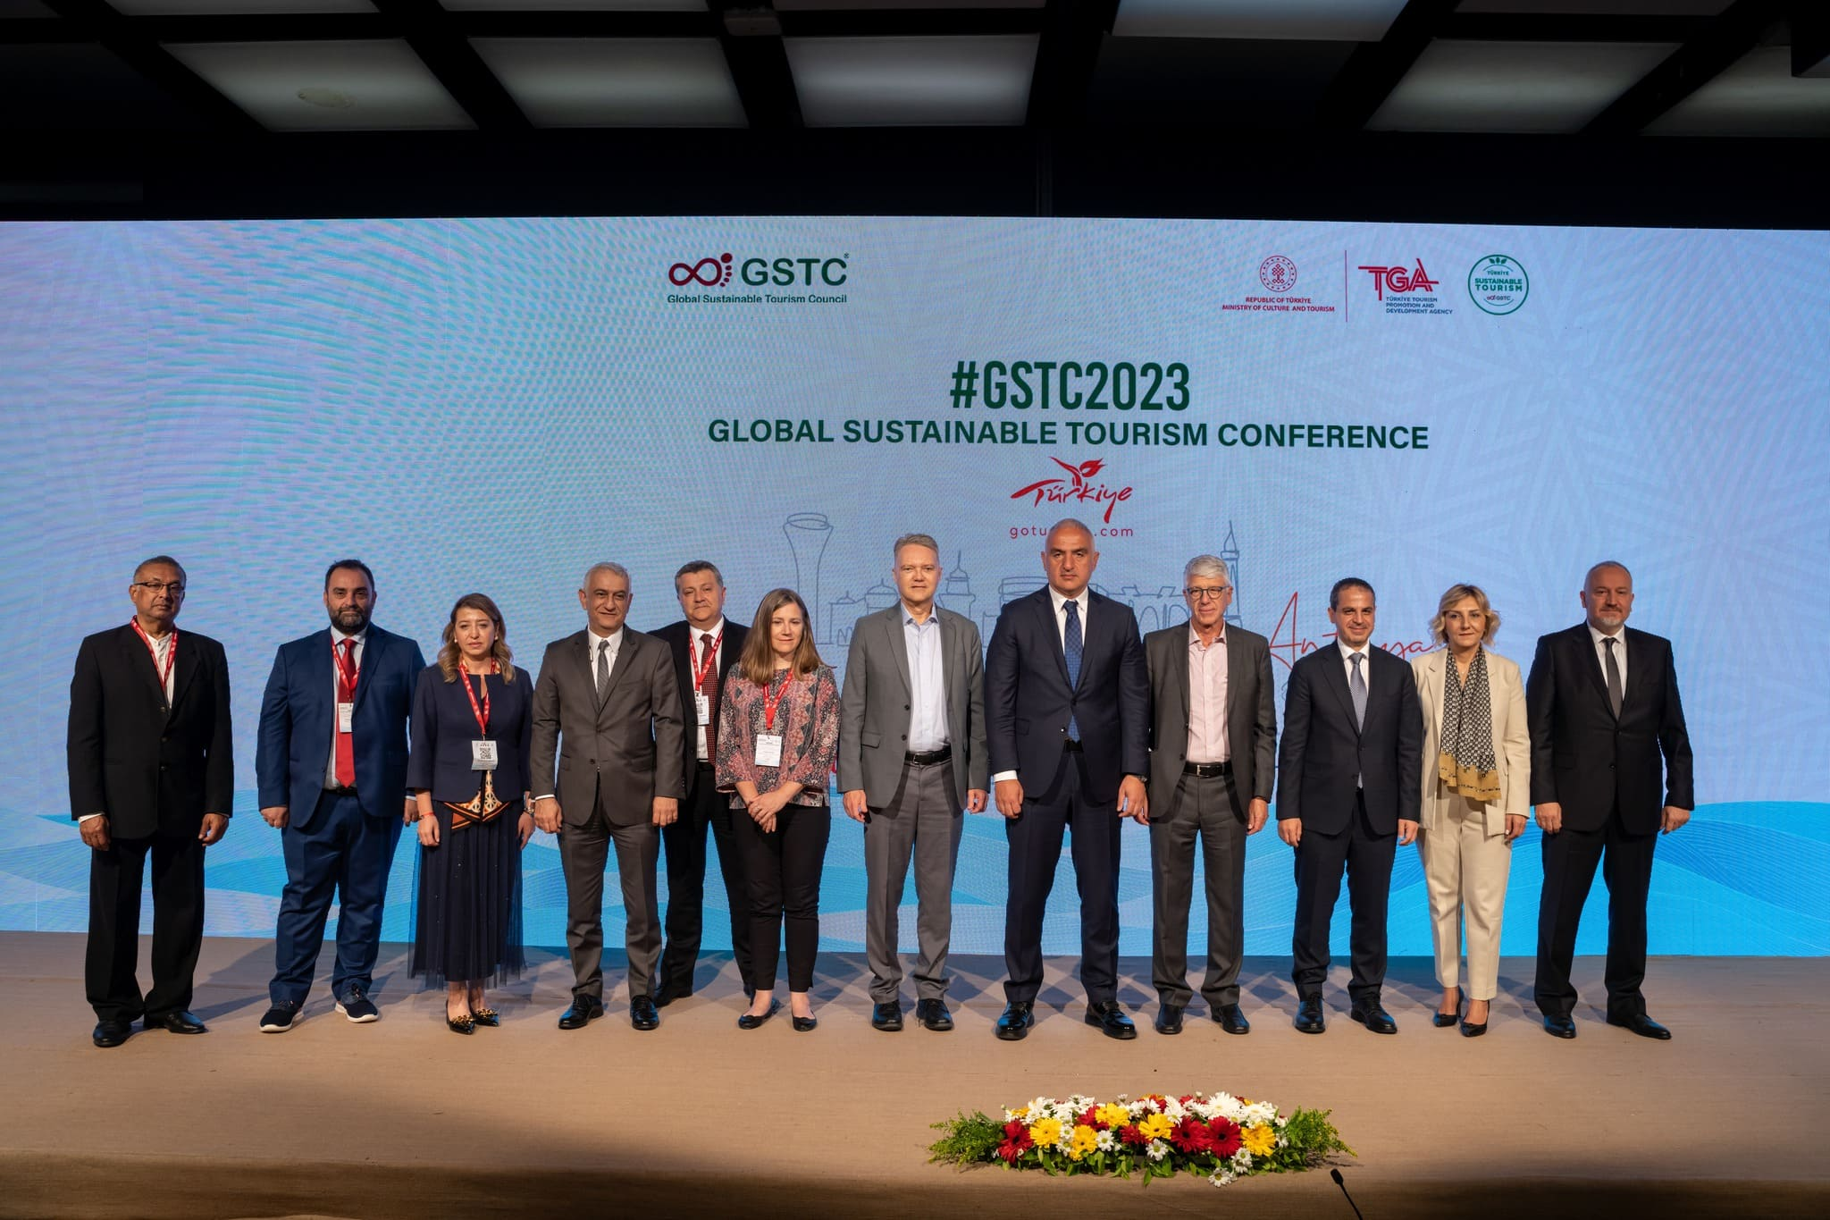
The #GSTC2023 Global Sustainable Tourism Conference that took place on May 9th-12th in Antalya, Türkiye, brought together 350 delegates from 51 countries, along with hundreds of viewers that watched the live broadcasting of the conference. The conference was held at the Nirvana Cosmopolitan Hotel.
Participants included international and regional tourism stakeholders involved in developing and promoting sustainable tourism; including the public sector, hotels, tour operators, academia, development agencies, NGOs, consultants, and more. International participants came from Europe, North America, Latin America, Africa, Asia, and Oceania.
This year’s Conference focused on Destination Stewardship, Hotel Sustainability, Sustainable Tours, Experiences, and Attractions, and Sustainable MICE.

Mr. Luigi Cabrini, Chair, GSTC opened the conference by speaking about the uncertainties the industry is facing “This year we witness a strong recovery of international and domestic tourism, after the dramatic drop of over 70% during 2020 and 2021, when millions of jobs were lost, thousands of enterprises went bankrupt, and destinations struggled to survive. Many of these destinations are now returning almost to normality, as people are eager to travel again, after lockdowns and travel restrictions. But we are still facing economic and geopolitical challenges, such as the war in Ukraine, a high inflation, and soaring costs of all components related to travel and tourism. In this uncertain context, international tourism, globally, is not expected to return to pre-pandemics levels before 2024 at the earliest.”
He also added how the GSTC Criteria has helped the industry achieve higher levels of sustainability “Time has shown that GSTC filled a gap by making available a framework that can serve both the private and the public sector to achieve higher levels of sustainability. The GSTC membership today includes tourism authorities of over 25 countries, together with leaders of the private sectors, NGOs, universities, destinations and many others. We welcome this variety as a strength for GSTC, where the tourism sector is represented in its multiple facets and interests.
Speaking at the conference's opening, Turkish Minister of Culture and Tourism Mehmet Nuri Ersoy expressed his pleasure at hosting the most competent experts and opinion leaders of sustainable tourism in Türkiye. Ersoy said the GSTC 2023 Global Sustainable Tourism Conference would become a valuable information and idea exchange platform, creating significant gains for sustainable tourism worldwide. Minister Ersoy also noted that beyond acting as a pioneer by becoming the first country in the world to sign an agreement with GSTC for a national sustainability program at the governmental level, it had already become a global leader in sustainable tourism practices.
Ersoy added that Türkiye already has more than 1300 accommodation facilities with sustainability certificates or verifications in Türkiye’s Sustainable Tourism Program. Nearly 200 accommodation facilities have fully met the GSTC Criteria.

Speakers from across the world shared insights and discussed the following topics: Port Destinations and Sustainability, Sustainable Coastal Destinations, Sustainable Rural Tourism, Hotel digitalization solutions, Sustainability in Resorts, Culture and Nature Experiences, Sustainable Attractions, Booking.com and its Travel Sustainable Program, Tour Operators’ Preferred Contracting, Sustainable Tourism in the Balkan Region, and Inclusivity in Tourism.
During the Conference, a special panel discussion by the World Economic Forum addressed how sustainable tourism is a driver for resilient economies and societies. Also, several workshops were carried out for the development of the GSTC MICE Criteria and GSTC Attraction Criteria, and a Data Set workshop as well.
Recordings of the conference’s sessions can be found on the GSTC Facebook page. Presentations of the different sessions can be found on our website.
Prior to the conference, a GSTC Sustainable Tourism course took place, with 29 industry professionals from 12 different countries. Using the GSTC Industry Criteria and GSTC Destination Criteria as the foundation, the training class covered various topics relevant to our industry and the sustainability challenges and opportunities we are facing today.
The #GSTC2023 Global Conference which started with a welcome reception at Perge Ancient City with live music and food ended with a farewell cocktail dinner and show at Nirvana Cosmopolitan Cosmo’s Theatre. After the 2-day conference, participants joined a complimentary tour of Antalya the next day visiting Kaleiçi, Antalya’s Old Town, and a guided tour at the Antalya Museum. The tour provided an opportunity to explore the area’s rich cultural heritage and stunning architecture, its city’ past and present.
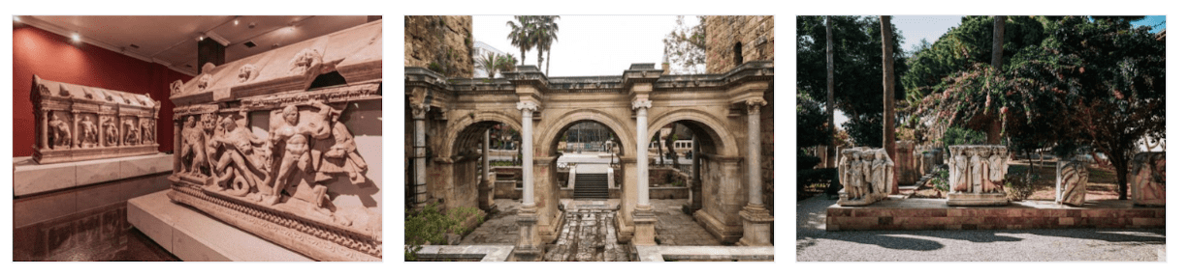
Photos from the conference are available on the GSTC Facebook page.

GSTC2024 Conferences
At the closing ceremony, the next GSTC Conferences were announced – #GSTC2024Sweden (23rd to 26th April 2024), and #GSTC2024Singapore (13th to 16th November 2024).


Carbon Footprint Measurement Sponsors and Other Sustainable Practices during the Conference
As with previous GSTC Conferences, the carbon footprint of the event and the travel of all attendees have been calculated and offset. Control Union sponsored the measurement, calculation, and reporting. Bureau Veritas sponsored the verification of this measurement. After the carbon footprint measurement and verification process, the carbon amount resulting from the measurement will be offset by TGA.
Other sustainable event practices were carried out, such as reducing paper and plastic usage to a minimum: printing to the minimum, badges were made of recyclable paper with seeds, so it could be planted and converted into flowers, lanyards were given back to be reused, without single-use plastic during the conference. In order to avoid printed materials while ensuring the communication between the conference participants, the Event Magix GSTC Antalya 2023 conference app was provided by ODS Tourism. Through the app, program flow was transmitted to our guests via notifications.
Local products and flavors were preferred during coffee breaks and dinners, special menus with reduced meat dishes and tasty vegan and vegetarian options were prepared, and products were completely provided by local suppliers.
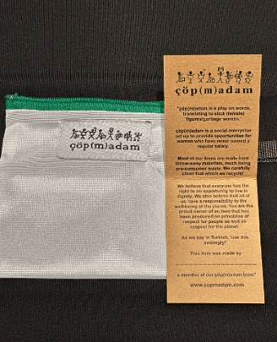
Broadcloth was used in the stage and stand installations and the use of printed fabric and paper was avoided as much as possible. The wallets made by “ÇöpMadam”, which were inside the promotional cloth bags of Go Türkiye, were handmade by women that have never earned a regular salary and made from waste fabrics. The fabrics that were used in some areas at the conference were delivered to ÇöpMadam and will be converted into bags to be distributed as gifts for TGA’s next event.
The hotel chosen for the event, Nirvana Cosmopolitan, and the Lara Barut Hotel where the dinner of day 1 was hosted, are Türkiye’s Sustainable Tourism Program third stage, meaning they are certified to the GSTC Criteria. Also, the waste of Nirvana Cosmopolitan Hotel was collected and delivered to the Depo Sanat company, which processed and turned it into a work of art. The piece made from waste was presented to all participants in the conference area.
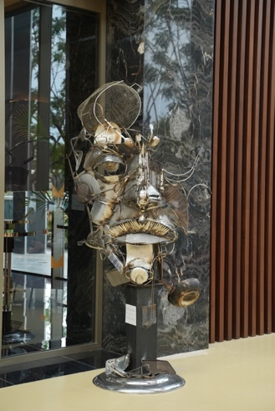

Turkey sets an example to the world in the field of sustainable tourism
With the cooperation agreement signed with GSTC at the beginning of 2022, Türkiye determined the road map the country will follow in sustainable tourism and accelerated its global sustainability practices. With this three-year protocol, the National Sustainable Tourism Program was established to restructure the tourism industry of Türkiye, which is the first country to agree with the government on sustainable tourism.

With the program, which includes destinations and tour operators, especially accommodation facilities, a sustainable transformation is aimed at the tourism industry in Türkiye. The program’s first phase, carried out gradually, will be completed this year, the second phase in 2025 and the third phase in 2030, and all international standards will be met.

Accommodation facilities must obtain a Sustainable Tourism Certificate within the scope of the Sustainable Tourism Program, which is based on the GSTC Industry Criteria developed for accommodation facilities in the first place. Accommodation facilities subject to independent evaluation are given a certificate. As of May 2nd, 2023, the number of enterprises that met the necessary criteria and received the 1st Stage verification was 1,188, the number of the 3rd Stage Certificate was 197. In 2030, within the program’s scope, it is planned that around 24,000 accommodation facilities in Türkiye will have a Sustainability certificate and move to sustainable tourism.

Acknowledgments
Our profound gratitude to all of those who have participated in making this event possible: TGA as an organizer and sponsor of GSTC, Etifor and Sevilla for being sponsors as well. Nirvana Cosmopolitan for providing the venue and Lara Barut Hotel for providing dinner for the first day. Our Exhibitors at the event: Control Union, RoyalCert, Amisol, Visit Swden, Tourism Singapore Board and Print Plast. And our Media Partners: Travel Daily News, Travindy, EcoClub, India Outbound and Ven America.
Thank you all for making an unforgettable #GSTC2023 in Antalya, Türkiye.
For updates about future conferences and other important developments, sign up for the GSTC monthly newsletter.

#END#

