**The Global Sustainable Tourism Council (GSTC) publishes new GSTC MICE Criteria**

19 March 2024 – The **Global Sustainable Tourism Council® (GSTC®)** is pleased to announce that the [**GSTC MICE Criteria**](https://www.gstcouncil.org/gstc-criteria/gstc-mice-criteria/) have been published and are available to the public for non-commercial use. Developed for Venues, Event Organizers, and Events & Exhibitions, the GSTC MICE Criteria, developed with support from the Singapore Tourism Board (STB), will guide businesses toward implementing sustainable practices in response to the growing focus on sustainability.

The **GSTC Criteria** serve as the global standards for sustainability in travel and tourism. The Criteria are used for education and awareness-raising, policy-making for businesses, organizations and government agencies, measurement and evaluation, and as a basis for certification. They are the result of a worldwide effort to develop a common language about sustainability in tourism and are arranged in four pillars: (A) Sustainable management; (B) Socioeconomic impacts; (C) Cultural impacts; (D) Environmental impacts.

The [**GSTC MICE Criteria**](https://www.gstcouncil.org/gstc-criteria/gstc-mice-criteria)are the third GSTC Criteria set, in addition to the [**GSTC Industry Criteria (for Hotels and Tour operators)**](https://www.gstcouncil.org/gstc-criteria/gstc-industry-criteria/) and the [**GSTC Destination Criteria**](https://www.gstcouncil.org/gstc-criteria/gstc-destination-criteria/). The **GSTC Attraction Criteria** are currently under development.

#### GSTC MICE Criteria

The **GSTC MICE Criteria** aim to serve as the global sustainability standards for Meetings, Incentives, Conferences and Exhibitions (MICE) businesses and provide a common understanding of sustainable practices in the MICE industry worldwide.

With the steady growth of the MICE industry coupled with the escalating demand for sustainable tourism, it is imperative to establish universal guidelines that prescribe sustainable practices to be adhered to by the various subsectors within the MICE industry. The **GSTC MICE Criteria** have been developed for the following subsectors: Venues, Event Organizers, and Events & Exhibitions, and are the minimum that any MICE business should aspire to attain.

“After a year of dedicated work and effort, we announce the formal release of the GSTC MICE Criteria for Venues, Event Organizers, and Events & Exhibitions. We thank the Singapore Tourism Board (STB), who has been a key contributor to its development. Let's seize this opportunity together to significantly advance the MICE industry's journey towards sustainability,” says **Randy Durband, CEO of GSTC.**

**Yap Chin Siang, Deputy Chief Executive, Singapore Tourism Board** said: “Our collaboration with the GSTC and SACEOS to develop the GSTC MICE Criteria underscores Singapore’s unwavering commitment to sustainable tourism and solidifies our position as a leading MICE destination. The MICE Criteria represents a major milestone on this journey, empowering industry players with the relevant tools to contribute to and thrive in a sustainable tourism landscape. I strongly urge all stakeholders in the MICE ecosystem to embrace the criteria and play a pivotal role in forging a greener future for global tourism.”

Singapore Tourism Board launched its MICE Sustainability Roadmap in 2022, demonstrating clear commitments towards its sustainability goals. This include launching local guidelines to provide best practices for MICE stakeholders on setting waste management goals and reducing specific types of waste, and to better manage carbon emissions. It has also worked closely with Singapore Association of Convention & Exhibition Organisers & Suppliers (SACEOS), as well as public and private stakeholders, to improve the sustainability performance of organisations and explore ways to host sustainable events.

[**Click here to see the new GSTC MICE Criteria**](https://www.gstcouncil.org/gstc-criteria/gstc-mice-criteria)

#### The GSTC MICE Criteria will:

* Help define sustainability in a holistic manner
* Raise awareness of the breadth and nature of sustainability
* Serve as the basis for certification for sustainability
* Offer both public and private sectors a starting point by providing basic guidelines for MICE businesses to become more sustainable, including guidance for identifying more sustainable suppliers and service providers
* Help consumers identify sustainable MICE businesses
* Serve as a common denominator for recognizing sustainable MICE businesses, helping businesses in choosing sustainable suppliers and partners
* Serve as basic guidelines for education and training on sustainable MICE practices
* Demonstrate leadership that inspires others to act

#### Development of GSTC MICE Criteria

The **GSTC MICE Criteria** have been built on decades of prior work and experience around the world and take into account the numerous guidelines and standards for sustainable tourism from every continent. During the development process, criteria were widely consulted throughout the globe, in both developed and developing countries. They reflect our goal of attaining a global consensus on sustainable tourism.

The Criteria have been developed and revised by following the GSTC Standard-setting Manual v3.0 while striving to adhere to the Standard-Setting Code of the ISEAL Alliance, the body recognized to provide guidance on international norms for developing sustainability standards in all sectors. More detailed information about the process development is available [here](https://www.gstcouncil.org/updates-on-mice-criteria-and-attraction-criteria-development/) and in the GSTC MICE Criteria Development Terms of Reference (TOR) [document](https://www.gstcouncil.org/wp-content/uploads/GSTC-MICE-Development_TOR_final_03.04.23.pdf).

GSTC MICE Criteria development process is shown below (Figure 1):

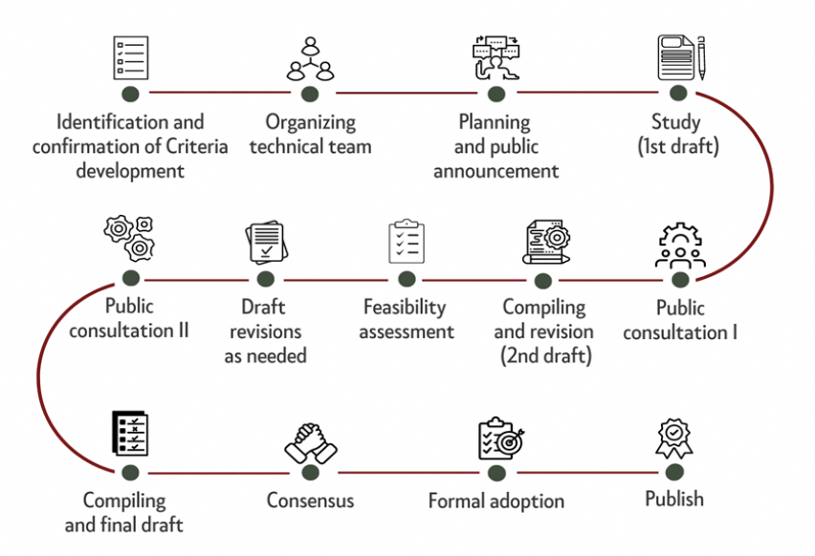

The Criteria development process was an 18-month-long journey from September 2022 to February 2024 (the formal period was 11 months, from [April 2023](https://www.gstcouncil.org/gstc-to-develop-new-mice-criteria/)). The [first round of public consultation](https://www.gstcouncil.org/gstc-mice-criteria-public-consultation-2/) took place for two months, from June 15th to August 15th, 2023. The key findings report is [available here](https://www.gstcouncil.org/wp-content/uploads/Report-on-the-key-findings-from-GSTC-MICE-1st-public-consultation_web.pdf).

After compiling and revising the second draft, a **Feasibility Assessment** was conducted to evaluate the suggested criteria based on a compiled draft from the GSTC Technical Team, and to assess the readability (how easy to understand the criteria are), measurability/auditability (how objective they are), and feasibility of the requirement (how likely they are to be met) of each criterion. The feasibility assessment took place from October 15th to November 15th, 2023. Organizations that took part in the Feasibility Assessment can be found in the annex below. [1]*

Revisions to the GSTC MICE Criteria draft were made after the [second public consultation](https://www.gstcouncil.org/mice-criteria-first-public-consultation-report-second-consultation-open/) period that was conducted from November 24th to December 29th, 2023. Final draft and consensus were made before the final adoption and publication.

**Sukumar Verma, Vice President, Industry & Enterprise, SACEOS**, said: “SACEOS is proud to have been a collaborative partner with the Singapore Tourism Board in developing the first GSTC MICE Criteria. We are also honoured to be part of the GSTC MICE Advisory Group to help shape the future of sustainable MICE and business events. As the national trade association representing Singapore’s MICE industry, we are grateful to our members for their valued inputs in championing the development of this comprehensive criteria. These standards provide a clear and actionable framework for businesses and organisations in sustainable event management for Event Organisers and Venues. The GSTC MICE Criteria will be instrumental in accelerating sustainable practices throughout the MICE sector both locally and globally.”

The GSTC will launch an ‘Early Adopter Program’ for the MICE Criteria. This program will run for two years, giving industry players the opportunity to apply the Criteria in the field and form a network for knowledge and experience sharing. Information on the Program will soon be announced. If you would like to get in touch before the announcement, please contact [criteria@gstcouncil.org](mailto:criteria@gstcouncil.org).

### GSTC Criteria & SDGs

There is a strong relationship between the [**GSTC Criteria**](https://www.gstcouncil.org/gstc-criteria/) and the United Nations **Sustainable Development Goals (UN SDGs).** By achieving the GSTC Criteria, organizations are helping to meet the UN SDGs. Economic, environmental, and societal dimensions are all addressed by the GSTC Criteria. Destinations and organizations looking to contribute to the SDGs will find that the GSTC Criteria provide effective tools to help them rise to the challenge. Further guidance on the criteria may be found in the supporting indicators and definitions set out in the publication.

### Acknowledgments

Along with GSTC and [Singapore Tourism Board (STB)](https://www.gstcouncil.org/gstc-to-develop-new-mice-criteria/), the Singapore Association of Convention & Exhibition Organisers & Suppliers (SACEOS), Singapore’s MICE industry association, has been a key contributor to the development of the **GSTC MICE Criteria**. We wish to extend our gratitude to all the organizations and individuals who participated in the development process for supporting our mission and providing their expertise and feedback.

A MICE Criteria Development Advisory Group [2]* was formed for the GSTC MICE Criteria development, which comprised ten organizations from both the public and private sectors with a proven history in organizing and hosting MICE events, to whom we wish to express our appreciation for playing a pivotal role in the development of the criteria. As well as to those who participated in the public consultation and the feasibility assessment, thank you for contributing to the development of the **GSTC MICE Criteria.**

Information about the GSTC MICE Criteria Development Terms of Reference (TOR) can be found in [this document.](https://www.gstcouncil.org/wp-content/uploads/GSTC-MICE-Development_TOR_final_03.04.23.pdf) More information about Criteria Development, Feedback & Revisions can be found [here](https://www.gstcouncil.org/gstc-criteria/criteria-feedback-revision/).

*[Note: As the owner of the GSTC Criteria, the GSTC reserves the right to assess and charge fees for the commercial use of the GSTC Criteria]*

[1]* Asian Ecotourism Network, Costa Rica Tourism Board, Edinburgh International Conference Centre (EICC), ExpoCité | Ville de Québec, International Congress and Convention Association (ICCA), Japan Convention Services, Malta Tourism Authority, Marina Bay Sands, Osaka International Convention Center Corp, Resorts World Sentosa, Sentosa Development Corporation, Singapore Association of Convention & Exhibition Organisers & Suppliers (SACEOS), Singapore Exhibition & Convention Bureau, Suwon Convention & Visitor Bureau, Türkiye Tourism Promotion and Development Agency (TGA).

[2]* The MICE Criteria Development Advisory Group included: Green Key Global, Osaka Convention Bureau, Singapore Association of Convention & Exhibition Organisers & Suppliers (SACEOS), Sustainable Hospitality Alliance (SHA), Suwon Convention Center, Visit Berlin, Visit Oslo, Singapore Tourism Board.

**#END#**

### About the Singapore Tourism Board

The Singapore Tourism Board (STB) is the lead development agency for tourism, one of Singapore’s key economic sectors. Together with industry partners and the community, we shape a dynamic Singapore tourism landscape. We bring the Passion Made Possible brand to life by differentiating Singapore as a vibrant destination that inspires people to share and deepen their passions.

More: [www.stb.gov.sg](http://www.stb.gov.sg/) or [www.visitsingapore.com](http://www.visitsingapore.com/) | Follow us: [STB LinkedIn](http://www.linkedin.com/company/singapore-tourism-board), [STB Facebook](http://www.facebook.com/STBsingapore) or [STB Instagram](http://www.instagram.com/stb_ig)

### About GSTC

The Global Sustainable Tourism Council® (GSTC®) establishes and manages global sustainable standards, known as the GSTC Criteria. There are three sets: [Destination Criteria](https://www.gstcouncil.org/gstc-criteria/gstc-destination-criteria/) for public policy-makers and destination managers, [Industry Criteria](https://www.gstcouncil.org/gstc-criteria/gstc-industry-criteria/) for hotels and tour operators, and [MICE Criteria](https://www.gstcouncil.org/gstc-criteria/gstc-mice-criteria/) for Venues, Event Organizers, and Events & Exhibitions. These are the guiding principles and minimum requirements that any tourism business or destination should aspire to reach in order to protect and sustain the world’s natural and cultural resources while ensuring tourism meets its potential as a tool for conservation and poverty alleviation.

The GSTC Criteria form the foundation for GSTC’s assurance role for Certification Bodies that certify hotels/accommodations, tour operators, and destinations as having sustainable policies and practices in place. GSTC does not directly certify any products or services, but provides accreditation to those that do. The GSTC is an independent and neutral USA-registered 501(c)3 non-profit organization that represents a [diverse and global membership](https://www.gstcouncil.org/membership/member-search/), including national and provincial governments, leading travel companies, hotels, tour operators, NGOs, individuals and communities – all striving to achieve best practices in sustainable tourism.

Information for media and the press: [www.gstcouncil.org/about/for-the-press/](http://www.gstcouncil.org/about/for-the-press/)

Image:

